**Udacity 257 – A/B testing**

P(hat)= X/N

To tall whether a binomial distribution is normal distribution >> N*P(hat) > 5 and N* (1-P(hat)) > 5

Confidence interval:

Marginal error (M) = Z score of the confidence interval * SE = $Z*\sqrt{\frac{Phat(1-Phat)}{N}}$

Marginal error is function of proportion of success and sample size – means need to consider the proportion of success when deciding the sample size.

P hat further from 0.5, the smaller the margin is.

Z score for the 95% CI is 1.96



**z-score table**

You can use [this z-score table](https://www.math.upenn.edu/~chhays/zscoretable.pdf).

If you don't recall how to read a z-score table, [this page](http://www.had2know.com/academics/normal-distribution-table-z-scores.html) contains instructions.

**Standard deviation of binomial**

If you look up a binomial distribution elsewhere, you may find that it has a mean of np*np* and a standard deviation of \sqrt{np(1-p)}*np*(1−*p*)​. This is for a binomial distribution defined as the total number of successes, whereas we will use the fraction or proportion of successes throughout this class. In this cas, the mean is p*p* and standard deviation is \sqrt{\frac{p(1-p)}{n}}*np*(1−*p*)​​.

**Useful equations**

You may find these equations helpful in solving the quiz:  


**Standard deviation of binomial**

If you look up a binomial distribution elsewhere, you may find that it has a mean of np*np* and a standard deviation of \sqrt{np(1-p)}*np*(1−*p*)​. This is for a binomial distribution defined as the total number of successes, whereas we will use the fraction or proportion of successes throughout this class. In this case, the mean is p*p* and standard deviation is \sqrt{\frac{p(1-p)}{n}}*np*(1−*p*)​​.



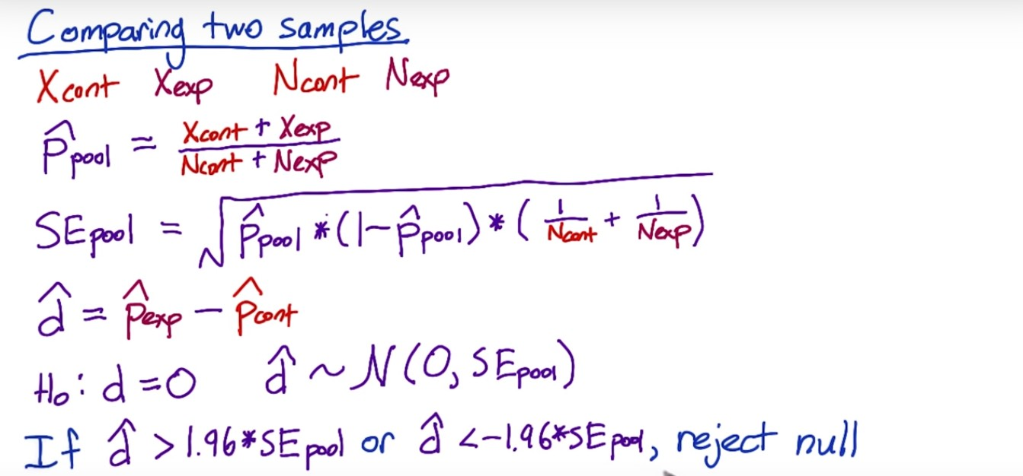

Question here for above:

* This falls under two sample comparison with variance unknown, should we use T test instead of Z? Why still 1.96? is it because the sample size is big so that T is close to Z?

Define the difference:

Statistically significant - repeatability

Practically significant / substantive – this depends on industry e.g. medicine vs. internet

Need to size the populations such that the statistical significance bar is lower than practical significance.



Power, or sensitivty: probably to reject null when null is not true (correct rejection) this is always 80%

**Power = 1 – beta**

In A/B test – power means to capture the significant changes

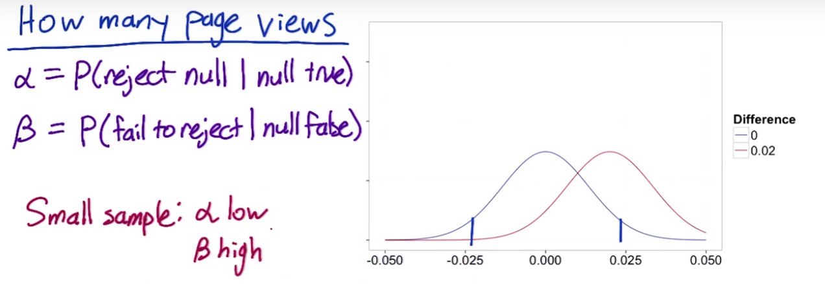

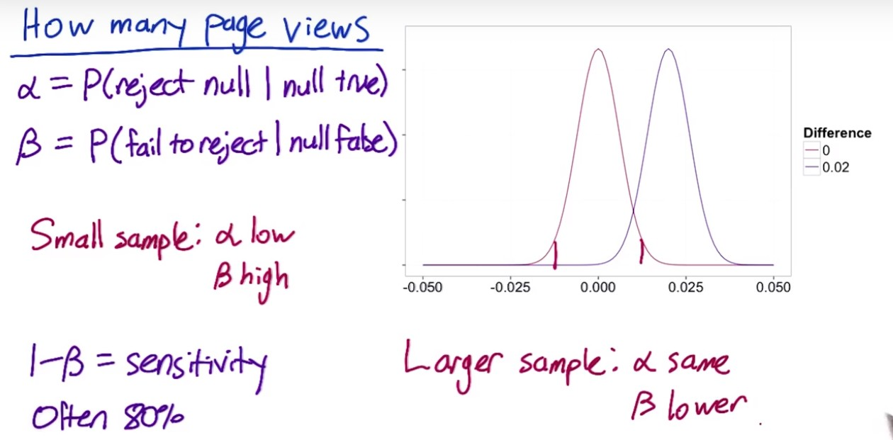



#1. Increase the standard error of the sample – means larger variance in your sample, and you need more data points to be more certain

#2. Larger changes are easier to detect than smaller changes, so do not need that many samples.

#3. Increase confidence interval – you want to be more certain that a change has occurred before you reject the null. More conservative – more samples needed (otherwise can reject less often, but power will decrease)

#4. Increase the power – need to collect more samples to narrow the distribution.

Note: for #3 and #4, the rationales are very similar. Power (1-beta) changes in the same direction with alpha, and opposite to confidence interval. So if CI increases, you need to increase sample size to keep same level of power (i.e. narrow the distribution, make the tail thinner and more concentrated around the center). Same for cases where power increases.

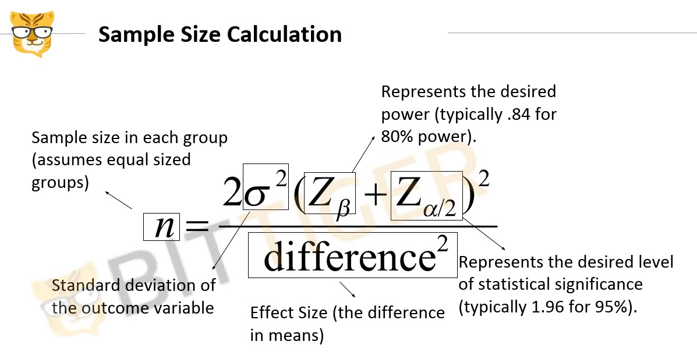

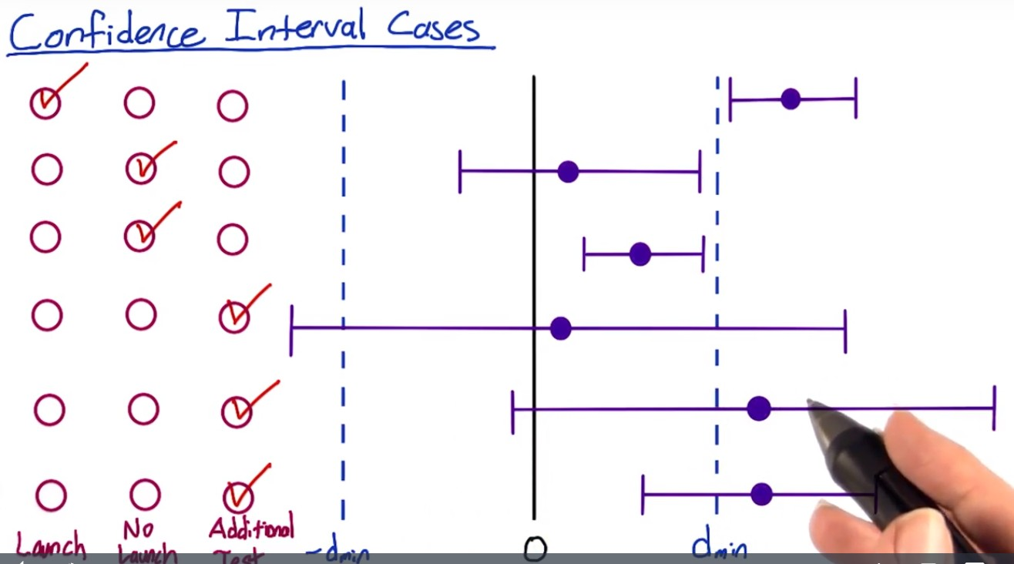

Case #2: CI includes 0 (neutral). Change is neither statistically nor practically significant.

Case #3: upper bound of CI is less than practical significance, and CI does not include 0. The change is statistically significant, but the magnitude is not large enough for you to care about.

Case #4 - #5: need to run test with larger power to draw conclusions.

**Four principles of AB Test**

## First Principle: Risk

**First**, in the study, what risk is the participant undertaking? The main threshold is whether the risk exceeds that of “minimal risk”. Minimal risk is defined as the probability and magnitude of harm that a participant would encounter in normal daily life. The harm considered encompasses physical, psychological and emotional, social, and economic concerns. If the risk exceeds minimal risk, then informed consent is required. We’ll discuss informed consent further below.

In most, but not all, online experiments, it can certainly be debated as to whether any of the experiments lead to anything beyond minimal risk. What risk is a participant going to be exposed to if we change the ranking of courses on an educational site, or if we change the UI on an online game?

Exceptions would certainly be any websites or applications that are health or financial related. In the Facebook experiment, for example, it can be debated as to whether participants were really being exposed to anything beyond minimal risk: all items shown were going to be in their feed anyway, it’s only a question of whether removing some of the posts led to increased risk.

## Second Principle: Benefits

**Next**, what benefits might result from the study? Even if the risk is minimal, how might the results help? In most online A/B testing, the benefits are around improving the product. In other social sciences, it is about understanding the human condition in ways that might help, for example in education and development. In medicine, the risks are often higher but the benefits are often around improved health outcomes.

It is important to be able to state what the benefit would be from completing the study.

## Third Principle: Alternatives

**Third**, what other choices do participants have? For example, if you are testing out changes to a search engine, participants always have the choice to use another search engine. The main issue is that the fewer alternatives that participants have, the more issue that there is around coercion and whether participants really have a choice in whether to participate or not, and how that balances against the risks and benefits.

For example, in medical clinical trials testing out new drugs for cancer, given that the other main choice that most participants face is death, the risk allowable for participants, given informed consent, is quite high.

In online experiments, the issues to consider are what the other alternative services that a user might have, and what the switching costs might be, in terms of time, money, information, etc.

## Fourth Principle: Data Sensitivity

**Finally**, what data is being collected, and what is the expectation of privacy and confidentiality? This last question is quite nuanced, encompassing numerous questions:

* Do participants understand what data is being collected about them?
* What harm would befall them should that data be made public?
* Would they expect that data to be considered private and confidential?

For example, if participants are being observed in a public setting (e.g., a football stadium), there is really no expectation of privacy. If the study is on existing public data, then there is also no expectation of further confidentiality.

If, however, new data is being gathered, then the questions come down to:

* What data is being gathered? How sensitive is it? Does it include financial and health data?
* Can the data being gathered be tied to the individual, i.e., is it considered personally identifiable?
* How is the data being handled, with what security? What level of confidentiality can participants expect?
* What harm would befall the individual should the data become public, where the harm would encompass health, psychological / emotional, social, and financial concerns?

For example, often times, collected data from observed “public” behavior, surveys, and interviews, if the data were not personally identifiable, would be considered exempt from IRB review (reference: NSF FAQ below).

To summarize, there are really three main issues with data collection with regards to experiments:

* For new data being collected and stored, how sensitive is the data and what are the internal safeguards for handling that data? E.g., what access controls are there, how are breaches to that security caught and managed, etc.?
* Then, for that data, how will it be used and how will participants’ data be protected? How are participants guaranteed that their data, which was collected for use in the study, will not be used for some other purpose? This becomes more important as the sensitivity of the data increases.
* Finally, what data may be published more broadly, and does that introduce any additional risk to the participants?

### Difference between pseudonymous and anonymous data

One question that frequently gets asked is what the difference is between identified, pseudonymous, and anonymous data is.

**Identified** data means that data is stored and collected with personally identifiable information. This can be names, IDs such as a social security number or driver’s license ID, phone numbers, etc. HIPAA is a common standard, and that standard has [18 identifiers (see the Safe Harbor method)](http://www.hhs.gov/ocr/privacy/hipaa/understanding/coveredentities/De-identification/guidance.html#standard) that it considers personally identifiable. Device id, such as a smartphone’s device id, are considered personally identifiable in many instances.

**Anonymous** data means that data is stored and collected without any personally identifiable information. This data can be considered **pseudonymous** if it is stored with a randomly generated id such as a cookie that gets assigned on some event, such as the first time that a user goes to an app or website and does not have such an id stored.

In most cases, anonymous data still has time-stamps -- which is one of the HIPAA 18 identifiers. Why? Well, we need to distinguish between anonymous data and anonymized data. **Anonymized data** is identified or anonymous data that has been looked at and guaranteed in some way that the re-identification risk is low to non-existent, i.e., that given the data, it would be hard to impossible for someone to be able to figure out which individual this data refers to. Often times, this guarantee is done statistically, and looks at how many individuals would fall into every possible bucket (i.e., combination of values).

What this means is that anonymous data may still have high re-identification risk (see [AOL example](http://en.wikipedia.org/wiki/AOL_search_data_leak)).

So, if we go back to the data being gathered, collected, stored, and used in the experiment, the questions are:

* How sensitive is the data?
* What is the re-identification risk of individuals from the data?

As the sensitivity and the risk increases, then the level of data protection must increase: confidentiality, access control, security, monitoring & auditing, etc.



2. personal information tied to the data?

3. financial, health data? Or other less important data? individual level or group level?

4. secure access?

**Metrics:**

Need to think about how to use these metrics before defining them.

**(1) Sanity Checking / Invariant Checking:** to make sure the experiment is run properly.

These metrics should remain unchanged between control and experiment group

e.g. populations the same? Distribution the same?

**(2) Evaluation:**

a. high-level business metrics:

* Revenue, market share, how many users

b. more detailed metrics that reflect the user’s experience with the product

* Set up a set of techniques to help dig into the user experience – ,e.g. user experience research – e.g. users are not finishing a class – dig into the reason- quit too difficult, video of class too long?
* Some experiences might not have the information you need (e.g. do students have improved skills – very nebulous and cannot measure), or it takes too long to get the information– e.g. students get jobs after taking the class? Could be more than 6 months, and the experiment is too short for getting such info

**Define these metrics:**

**Step1: high-level concepts**

A one-sentence summary that everyone can understand – e.g. active users, click-through-probability

**Step2: Define the details**

What constitutes active users?

**Step3: take all these individual data measurements and summarize them into a single metric**

e.g. use median, sum, average, count, etc.

Evaluation – single or multiple metrics??

Depend on company culture and how comfortable people are with the data

Might want different teams to move towards the same goal, therefore in that case might want a single metric.

And if have multiple metrics, can create a composite metric – objective function or OEC (overall evaluation criteria – a weighted function that combines all these metrics)

Do not suggest using composite metric because:

(1) hard to define and get agreements from different groups

(2) can run into a problem if you over-optimize looking into one thing and do not look at others

(3) when the metric moves, people will come in and ask why it moves, and have to go back and check individual metrics anyway

Applicability:

Better to design a less optimal metric applicable to the whole suite of AB tests, than a perfect metric.

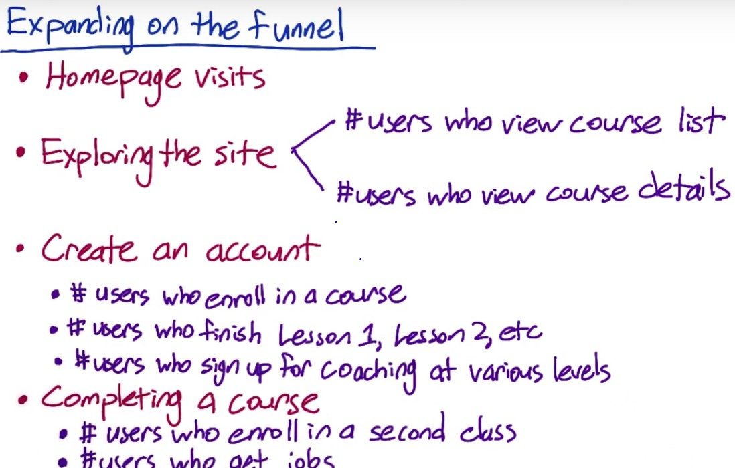

There might be swirls – customers from the later layer of the funnel go back to the earlier step – e.g. students finished lesson 2 of a course and enrolled in a different course.

Track steps across different platforms – iPhone vs. computer

Track the progress of the funnel across platforms.

Keep the counts at key steps (e.g. visit home pages, enroll in courses), and calculate rates at other steps.

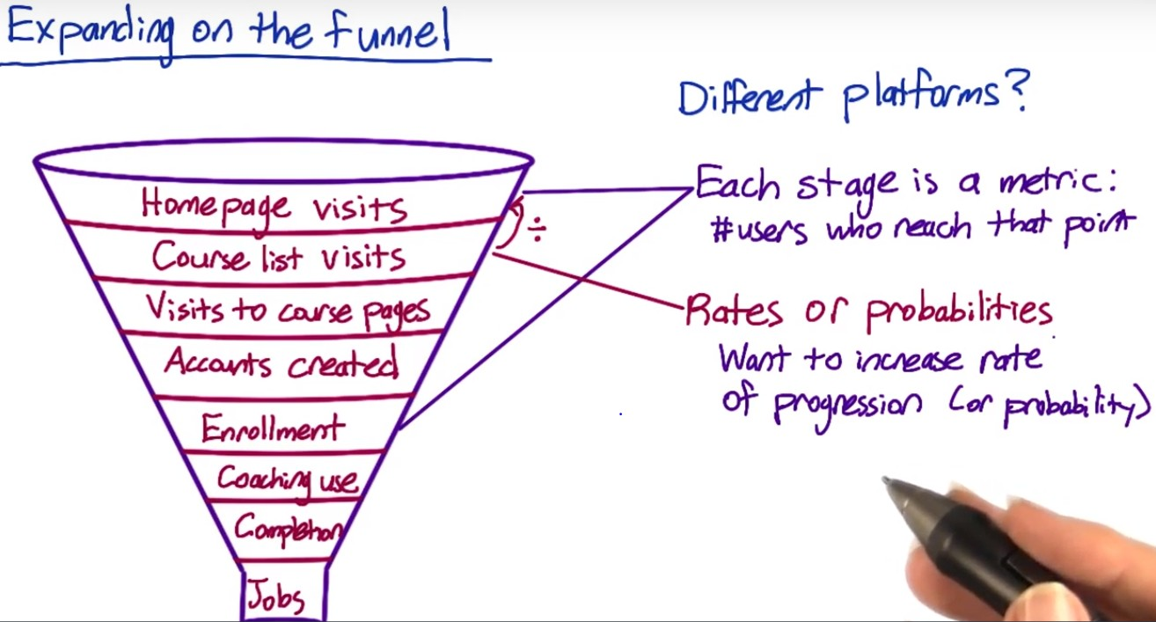

Might also care about whether or not a customer ever gets to a certain step – binary variable.

Probability – unique user that progress across the funnel.

Great work! Rates are often better than probabilities for measuring the usability of a button, and increasing the size of the "Start Now" button is probably an attempt to increase the usability. Thus, click-through-rate might have been a better choice. However, click-through-probability is a good choice as well.

Rates are better for assessing how easy it is to find the button.??? Refer to Diane in Lesson 1.

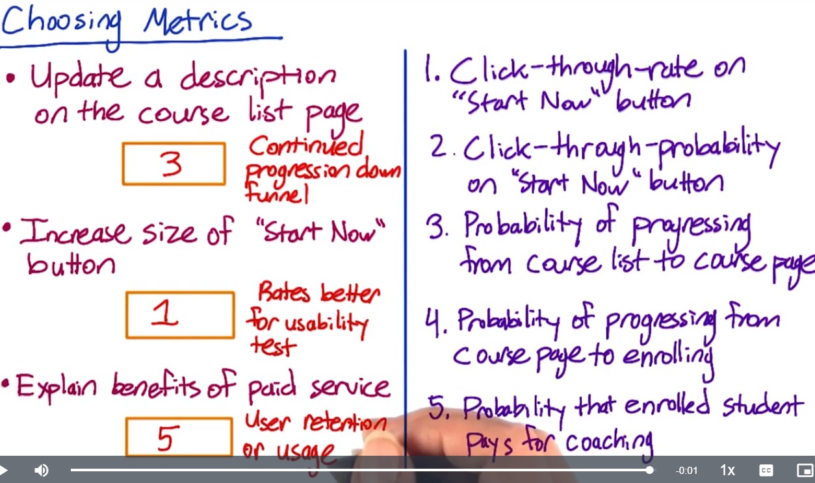

User retention: how long do students continue to pay for coaching?

Usage: Among the students who have got coaching services, now that students understand what coaches can do, do they use the coaching function more than before?

Difficult Metrics:

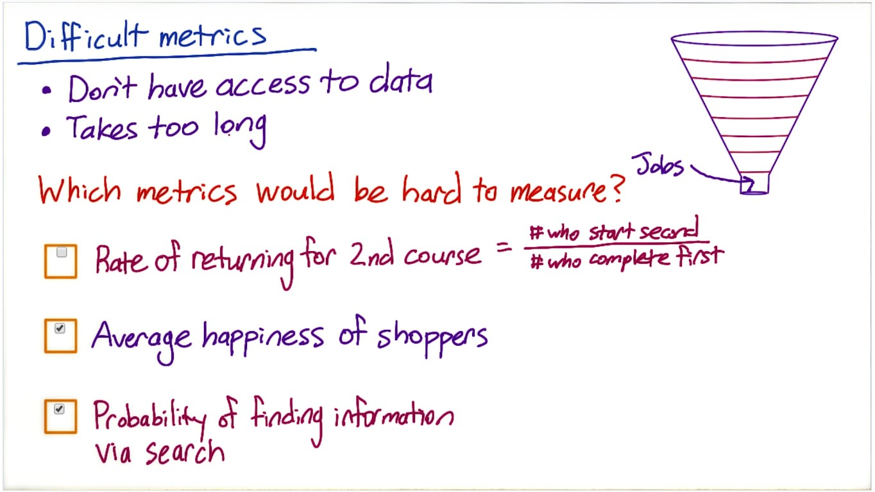

Other Metrics Techniques:

(1) Brainstorming to generate new ideas

(2) Validate possible metrics

(3) Develop validation technique based on how the external vendors analyze the data

1. companies that collect very granular data like market shares, websites with visitor data, etc.

2. companies run surveys of users – how many devices are you using? How much time are you spending on each of these devices?

3. academic research – establish metrics, correlation study,

Section #9 in Lesson #3 – hard to follow??

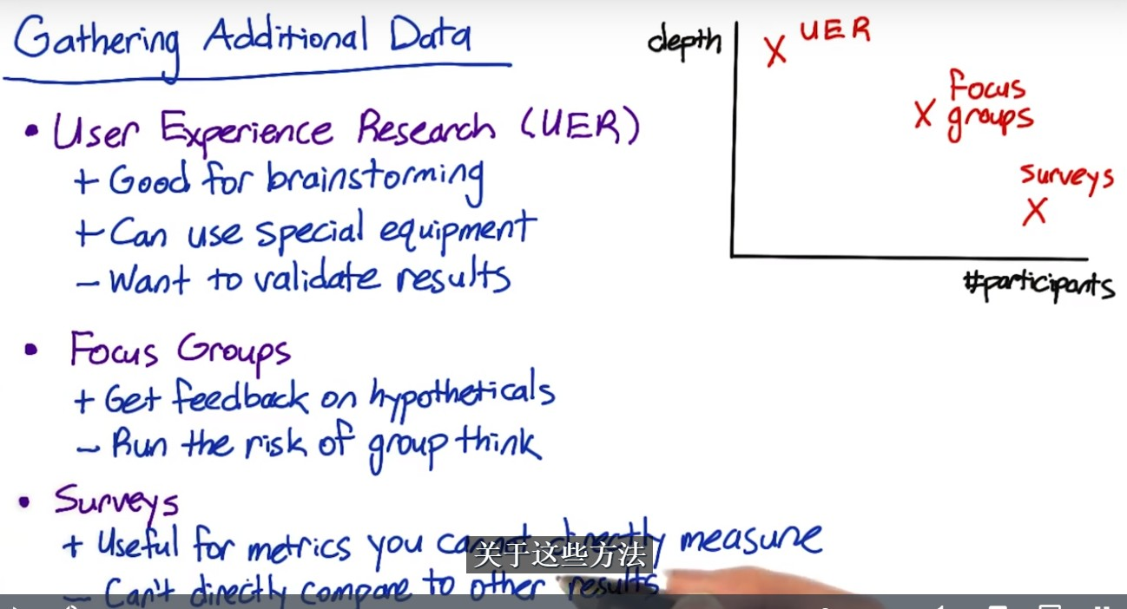

(1) User Experience Research: often only a few users but can go very deep.

Special equipment – e.g. special camera to capture eye movement

Validate results

Want to make sure that you validate the results of UER with retrospective analysis.

(2) Focus Groups:

More users, but less deep

Can show screenshots of images, walk through the demo and ask questions, including hypothesis questions.

(3) Surveys:

e.g. how many students get jobs after the course – whether the course contributes to them finding jobs

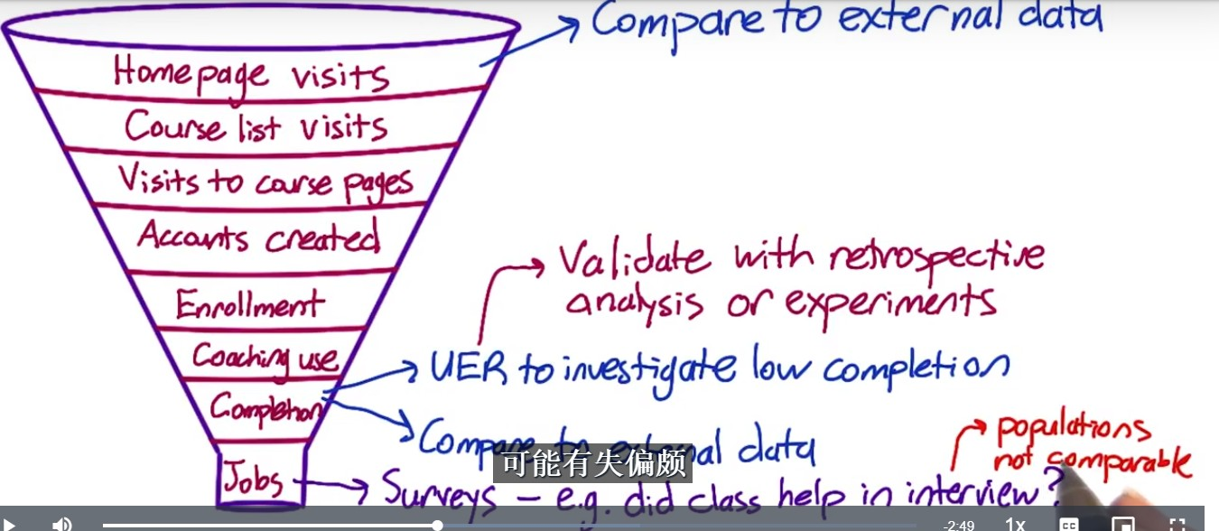

**UER for a particular course with low completion:**

Watch the students complete the lesson – understand where to click? Can they find all the info on the screen? Do they follow the order? How are they interacting with the coach? Waiting for video to load – latency? Link for the additional materials used?

For potential metrics identified via UER – use retrospective analysis to examine how the metric varies over time, or run some new experiments to see how that metric vary as you make changes

**Unmeasurable metric – Survey**

e.g. send emails to ask whether interview questions were covered by the course before.

Surveys are very helpful for the metrics hard to measure, but cannot compare the numbers from the survey directly with numbers from the other measurement as the populations are not the same. Survey population might be biased compared to internal data.

*********************************

**Rate of returning to 2nd course:**

(1) Survey to find out the reason to return to 2nd course

If something measurable predicts the return, can use it as a proxy.

**Average happiness of shoppers**

Find things correlated – survey at the end of the purchase, or UER.

**Searcher find the information they were looking for?**

Possible proxies:

* Length of time spent on the search page
* Whether the client clicks on the results shown on the page
* Whether there are any follow-up queries to try to find information in a different way
* Look at external data about information-finding research
* Run a UER
* Human Evaluation = pay human rator to evaluate your site.

**Student’s engagement in class:**

* Survey to ask students how engaged they are
* UER – observe how students interact with the course, and find whether the engagement correlates to something easier to measure, such as the time spent on a page or clicking more links on extra materials
* Can also do a retrospective analysis to see the behaviours correlated with students’ engagement in history.

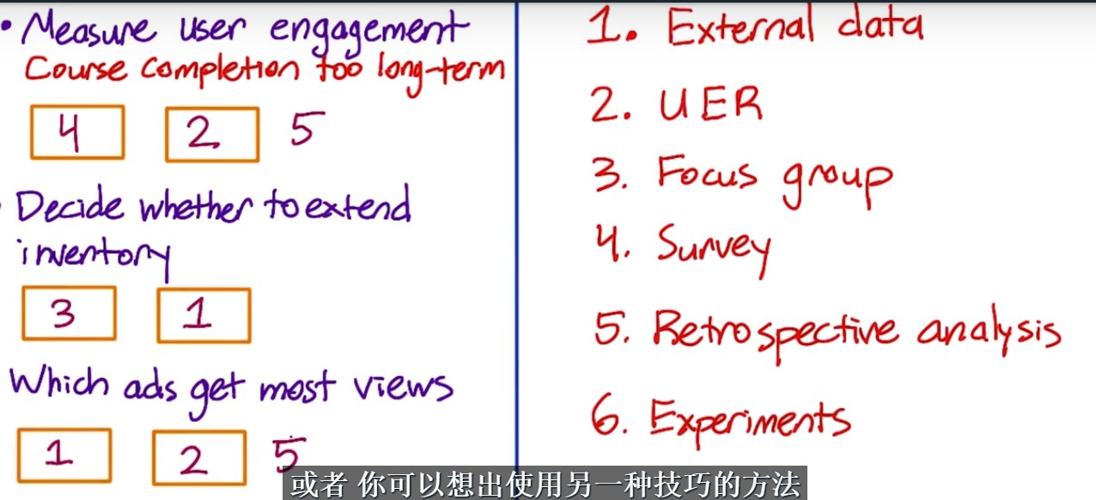

Ads:

#1. Check external research and find proxy

#2. UER – use special camera to observe which ads they are paying attention to

#3. Clicks relative to views – use clicks / or the lowest position that was ever clicked. And do retrospective analysis to find correlated factor.

Build intuition about your metric, your data, and your system

Should be able to understand what changes in your data and metric, your system can produce?

Need to first decide:

* Given the events that we observed, which are the ones that should count for those metrics and how to combine them (e.g. numerator, denominator)

e.g.

click-thru-rate

* Total number of clicks/ total number of views
* Cookie -probablity

Need to watch for more detailed issues

e.g. a cookie and no click – after a day, the same cookie comes back, and 15 mins wait and then click – do you consider them to be the same record? Or page load and click are around midnight and fall under two days, do you consider them as same day event or separately?

e.g. different browsers or platforms – might be different click through rates, as the technology to collect the clicks are different

need to understand whether the clicks are really different, or just caused by the underlying technology difference.

### Metric definitions

Def #1 (Cookie probability): For each <time interval>, number of cookies that click divided by number of cookies

Def #2 (Pageview probability): Number of pageviews with a click within <time interval> divided by number of pageviews

Def #3 (Rate): Number of clicks divided by number of pageviews

If a user refreshes the page within the same time interval, Def #1 and Def #2 will be different

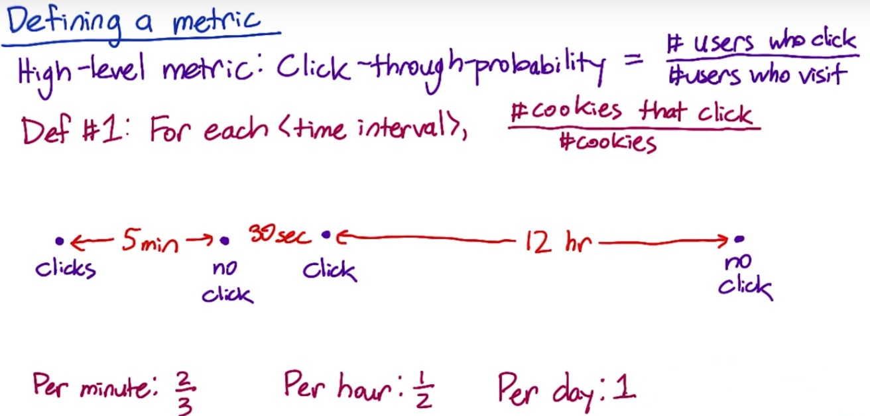

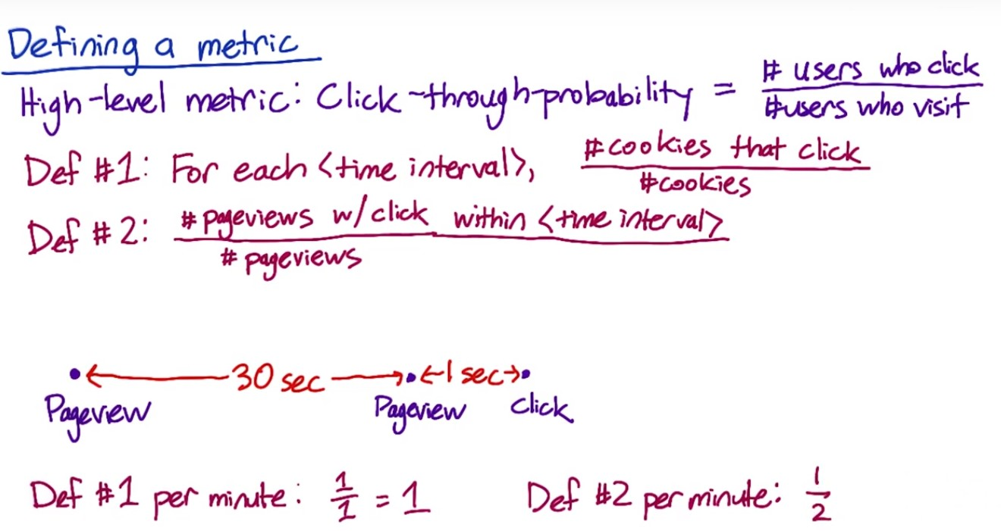

**Filtering and Segmenting**

External factors to consider:

Abuse on your site such as spam. Fraud

e.g. competitor clicking thru your website on everything

e.g. someone malicious trying to mess up your metric

e.g. additional traffic caused by a new experiment

need to at least flag and identify these issues, and eventually filter them out

Internal factors to consider:

Some changes only impact a subset of your traffic (only English Traffic), or only impact some platform – then need to filter only the affected traffic/platform

The goal is to debias the data.

**Note: watch not to introduce bias when do the filtering!**

e.g. filter the login users only – this filters out new uses who are trying the site.

e.g. filter out the long and weird conversation – should make sure these issues were not caused by any system problem

How to tell if the data is biased or not?

Segmenting the data, and calculate the metric on these various disjoint segments (e.g. country, language, platform).

See if the traffic is moved disproportionally across segments

Look at Day over Day or Week over Week traffic pattern changes to identify things that are unusual.

Looking at different segments can be useful for evaluating metric definition as you can look at how the metric varies by segments. This can help build intuition about your data and system.

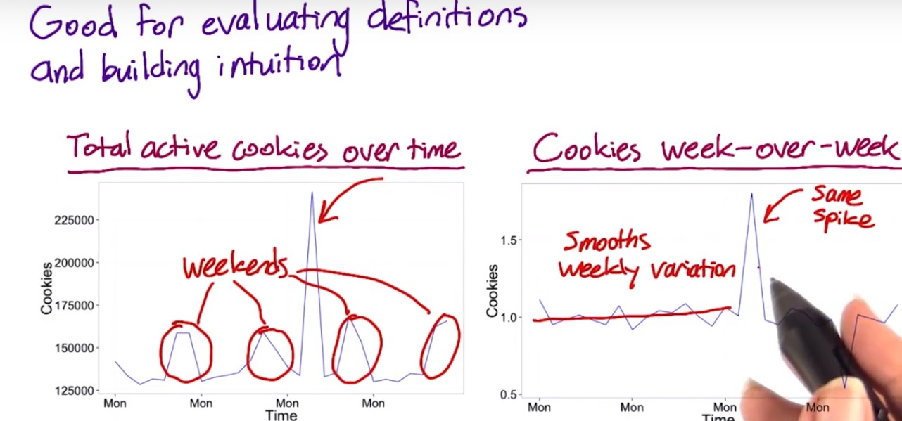

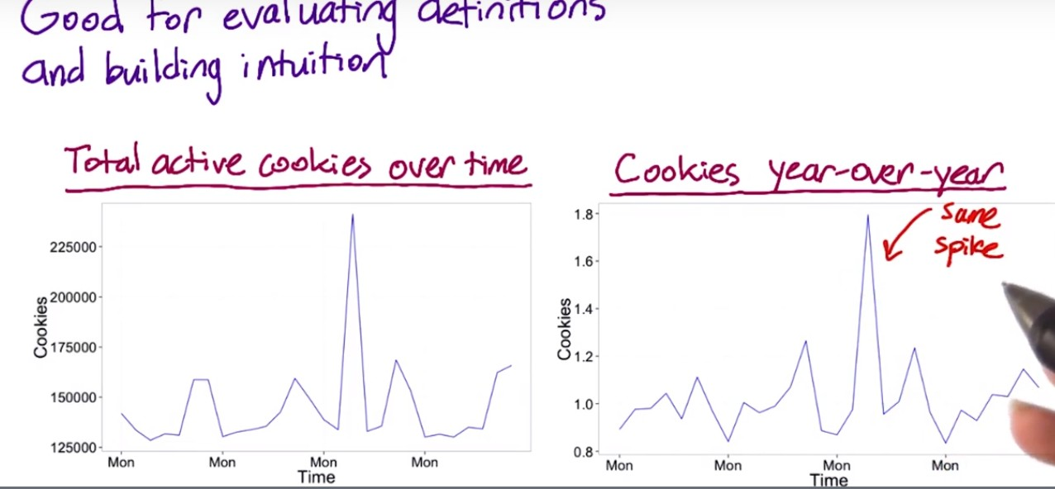

The spikes are still observed, indicating that it is not caused by WoW or YoY variation.



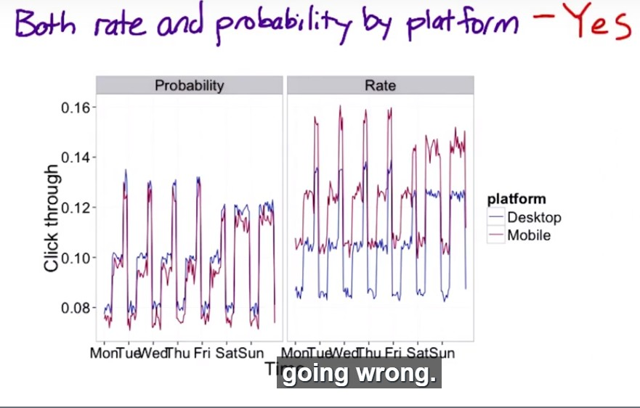

**Summary statistics – four broad categories**

(1) Sums and Counts – e.g. number of users visit the website

(2) Distributional metrics - e.g. means, median, percentiles.

(3) Rates or probabilities

(4) Ratio – range of different business models, but it is very hard to categorize

### Common distributions in online data

Let’s talk about some common distributions that come up when you look at real user data.

For example, let’s measure the rate at which users click on a result on our search page, analogously, we could measure the average staytime on the results page before traveling to a result. In this case, you’d probably see what we call a [Poisson distribution](http://en.wikipedia.org/wiki/Poisson_distribution), or that the stay times would be [exponentially distributed](http://en.wikipedia.org/wiki/Exponential_distribution).

Another common distribution of user data is a “power-law,” [Zipfian or Pareto distribution](http://en.wikipedia.org/wiki/Pareto_distribution). That basically means that the probability of a more extreme value, z, decreases like 1/z (or 1/z^exponent). This distribution also comes up in other rare events such as the frequency of words in a text (the most common word is really really common compared to the next word on the list). These types of heavy-tailed distributions are common in internet data.

Finally, you may have data that is a composition of different distributions - latency often has this characteristic because users on fast internet connection form one group and users on dial-up or cell phone networks form another. Even on mobile phones you may have differences between carriers, or newer cell phones vs. older text-based displays. This forms what is called a mixture distribution that can be hard to detect or characterize well.

The key here is not to necessarily come up with a distribution to match if the answer isn’t clear - that can be helpful - but to choose summary statistics that make the most sense for what you do have. If you have a distribution that is lopsided with a very long tail, choosing the mean probably doesn’t work for you very well - and in the case of something like the Pareto, the mean may be infinite!

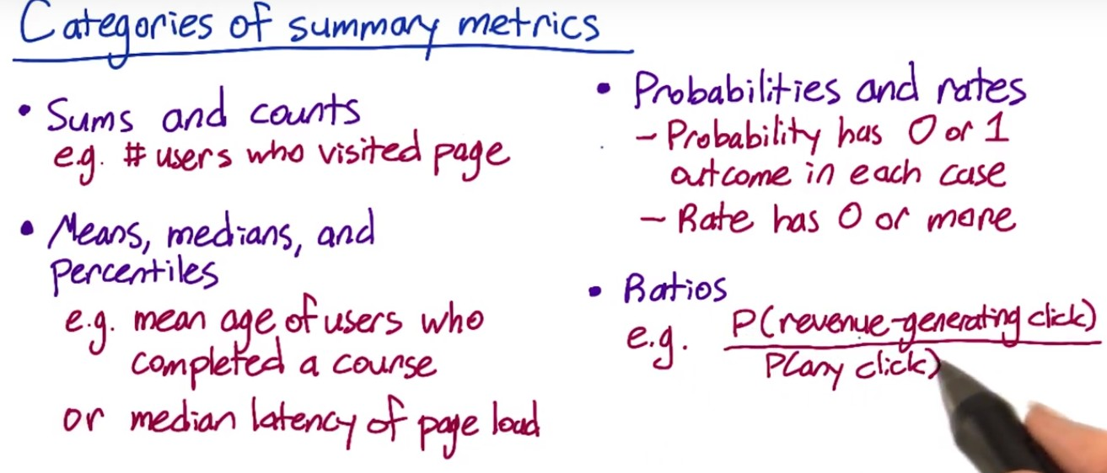

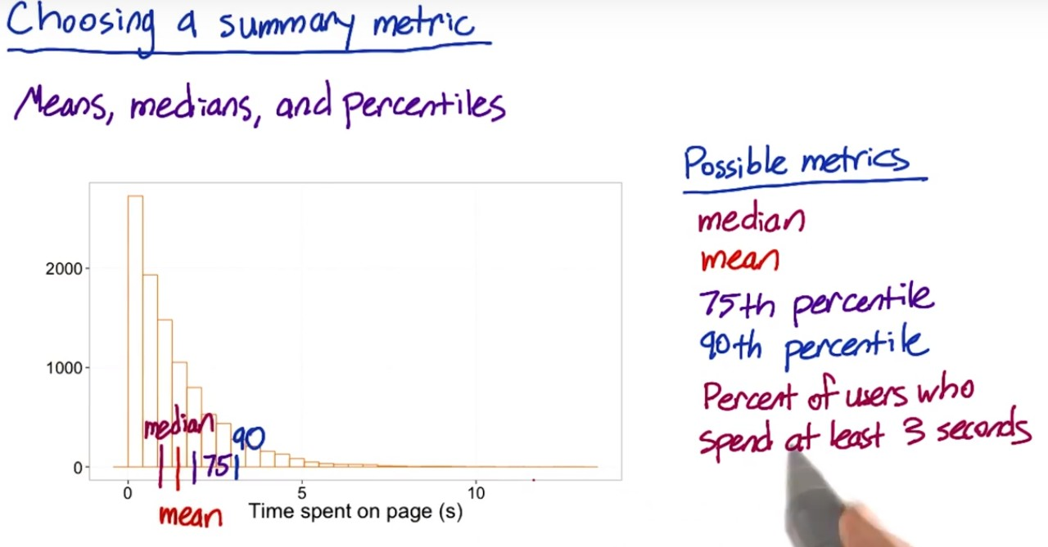

**Sensitivity & Robustness**

Metric should pick up the changes you care about (sensitivity) and does not pick up the changes that you do not care about (robustness).

e.g. mean is sensitive to outliers and heavily influenced by these observations

the median is less sensitive and more robust, but if you only affect a fraction of users, even a large fraction like 20%, the median might not change.

Can consider 90th, 99th percentile…

How would you measure the sensitivity and robustness?

**A. Experiment**

#1. Run experiment or use experiments already have

e.g. latency – increase the quality of video (increase the load time for users), and see if the metric responds to that

can look back at the experiments run by your company earlier – see if these experiments move the metrics you are interested in

#2. A/A experiment

Compare people seeing the same thing to each other. See if the metric picks up the difference between the two. Make sure you don’t call things significant that really do not mean anything

Example: Videos from 1 to 5 with decreased resolution

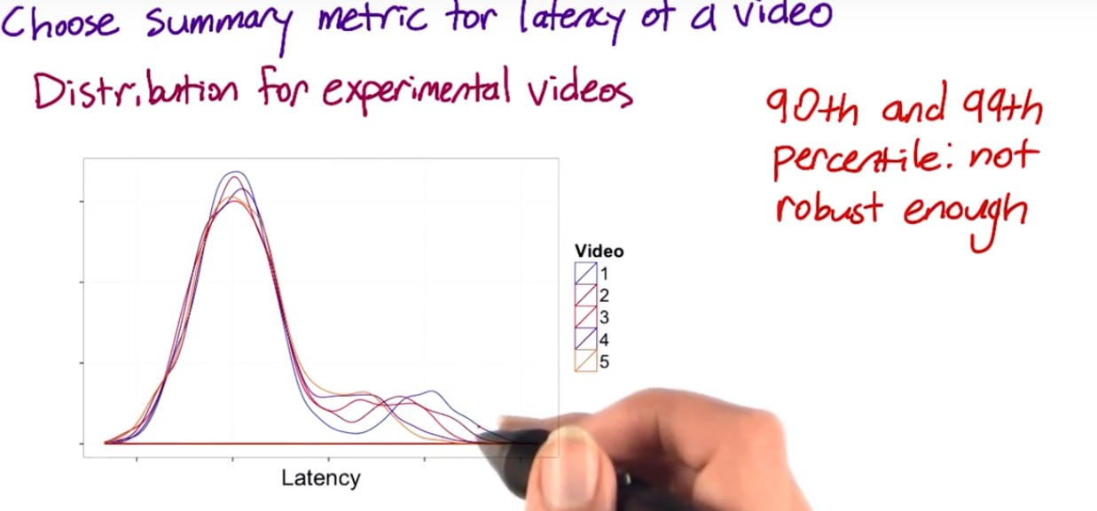

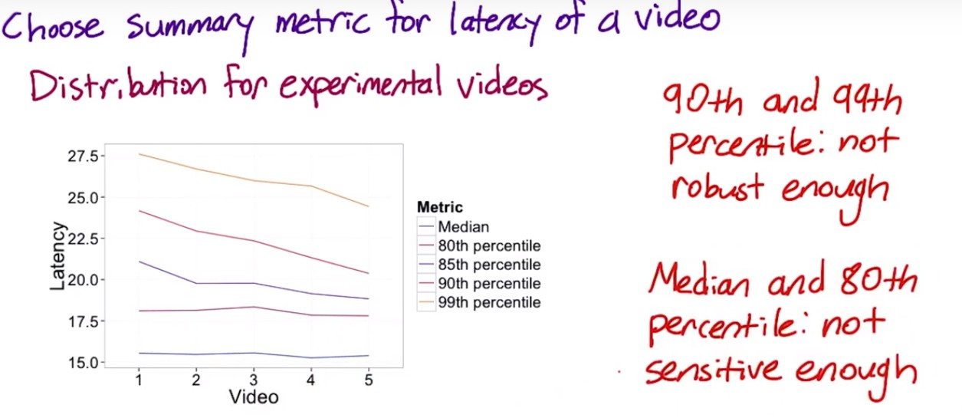

Median and 80th are not responding to the factor we care about

**B. Retrospective analysis**

Look back at the changes on your website, and see if the metrics you are interested in move in conjunction with these changes.

Or can look at the history of the metrics and see if there is anything that causes these changes.

Example: Video latency:

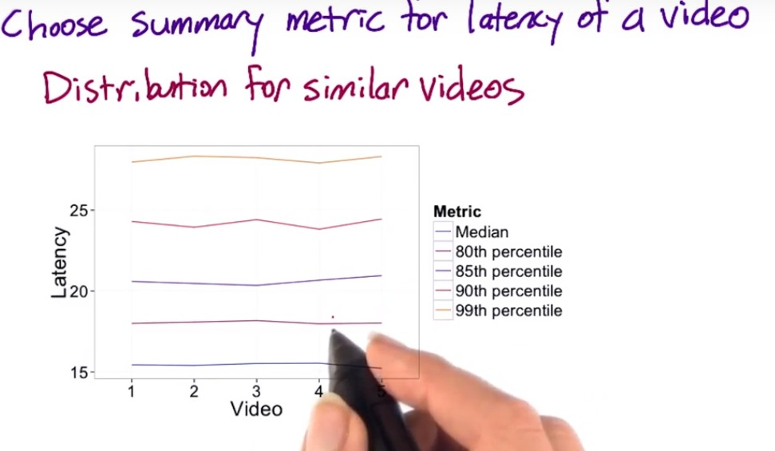

Compare the distribution metrics across samples and examine the stability. – 90th and 99th percentile are not robust

Need to make sure the videos are comparable! – resolution for example

**Difference: Absolute or relative – how are we going to compute the difference between the experiment and control**

* **Absolute difference:** if you just get started with the experiment and want to understand the possible metrics
* **% change advantage:** only need to pick one practical significance boundary to get stability over time
  + Seasonality (e.g. shopping behavior)
  + Your system changes over time

**Variability**

Need to check if the practical significance we choose is realistic for our metric – if we have a metric that varies a lot under normal circumstances, it might not work because the practical significance is just not feasible for the metric.



Question – Count- why only difference for this metric??

Note: for the median, the distribution of the median depends on the distribution of the underlying data (if the underlying data is normal, then it is normal)



**Non-parametric methods:** analyze the data without making assumption on what the distribution is

e.g. sign test – run A/B experiment for 20 days. 15 days, experiment has higher measurement than control. Use the binomial to calculate how likely it is to occur if there is no difference. Downside – does not help assess the size of the effect? Upside: easy to do and can do under different circumstances. – did not understand?? Lesson #23

Look at the summary statistics distribution

* If it is nice and normal, use the normal distribution and normal confidence interval with the variance you estimated empirically
* Otherwise calculate the nonparametric confidence interval

**Empirical Variances:**

For more complicated metrics, you might have to estimate the variance empirically than analytically

Other reasons to use empirical methods – you make assumptions for the underlying data distribution. This might work for simple metrics, but not true for complicated metrics. And even for simple metrics, the variances could be under-estimated (refer to Lesson #5) by using analytical method.

Use **A/A test** to estimate the empirical variance of the metrics. – Same controls, and compare the difference so that the difference is driven by the underlying variability, such as system, user populations, etc. If you see a lot of variability in a metric in an A/A test, it might be too sensitive to use in experiment.

**Use of A/A test:**

* If already have an analytical calculation of confidence interval, can use A/A test to compare it with empirical results for sanity checking purpose. If the results you get is not in line with expectation, check if you make wrong assumption about the distribution of underlying data.
* Estimate the variance empirically in case you cannot calculate it analytically, and use the empirical variance to calculate the confidence interval.
* Directly estimate the confidence interval from the result of A/A test, without making any assumption about the distribution of the underlying data.

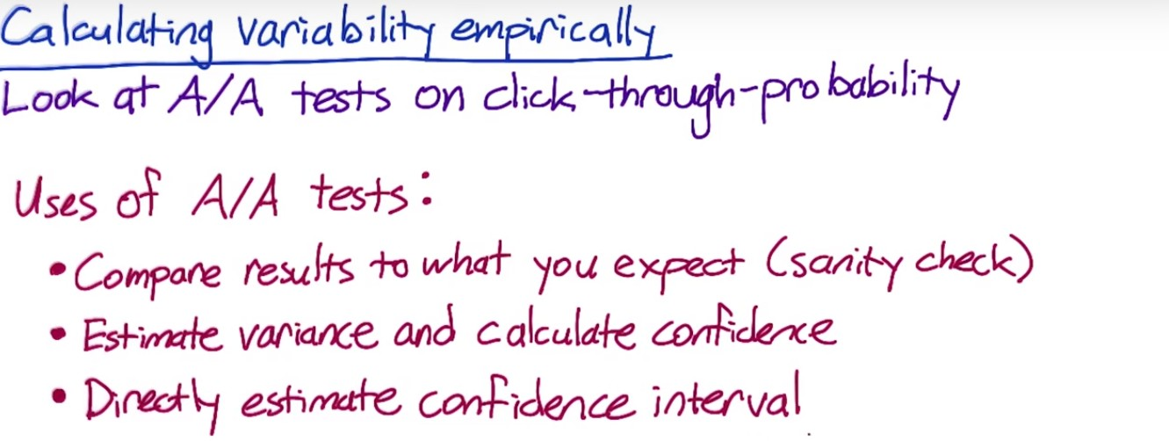

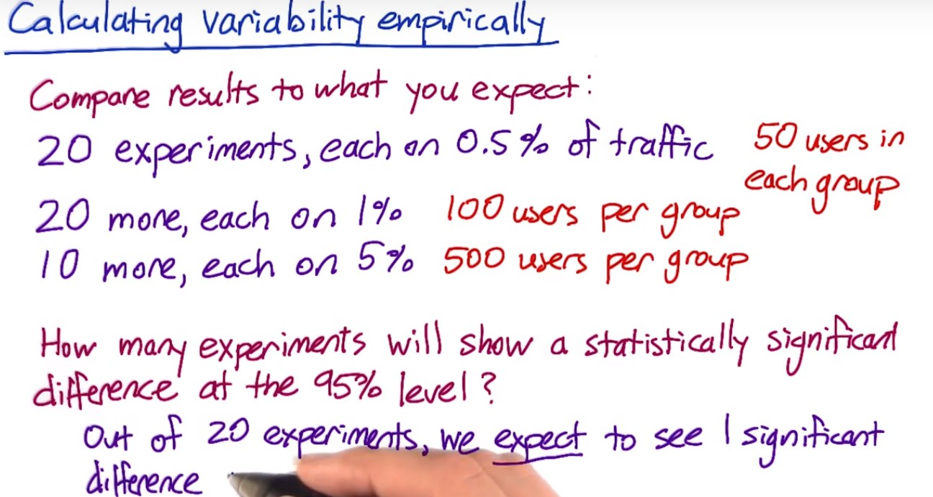

Note: since we are comparing the mean, one experiment is just one sample point.

**(1) Example 1: Sanity Checking:**

Based on the empirical data and the confidence interval derived from the analytical approach, only one significant difference in the 50 users experiment, and 0 in the experiments with 100 and 500 users. This is in line with expectations.

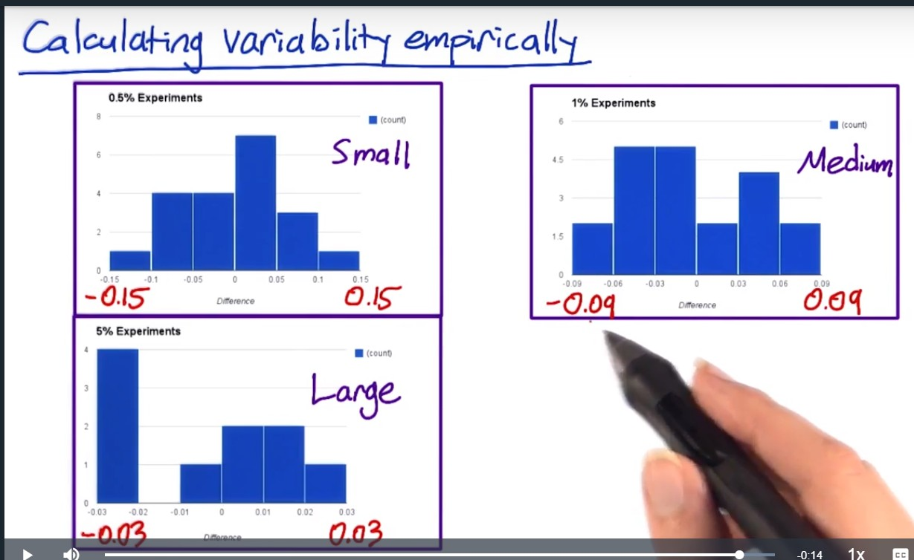

As the sample size grows, the distribution is closer to normal.

And the bigger the number of observations compared within each sample (experiment), the smaller the difference is, which is intuitive.

**(2) Example 2: Calculate empirical variability**

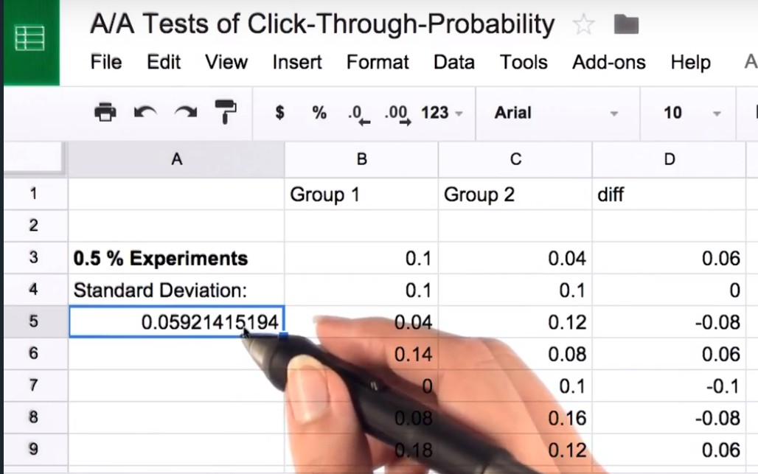



Note:

* Instead of calculating analytical variance for each experiment, derive an empirical variance across all experiments
* Can check the histograms of the differences to see if it follows normal distribution

**(3) Example 3: Directly estimate the confidence interval**

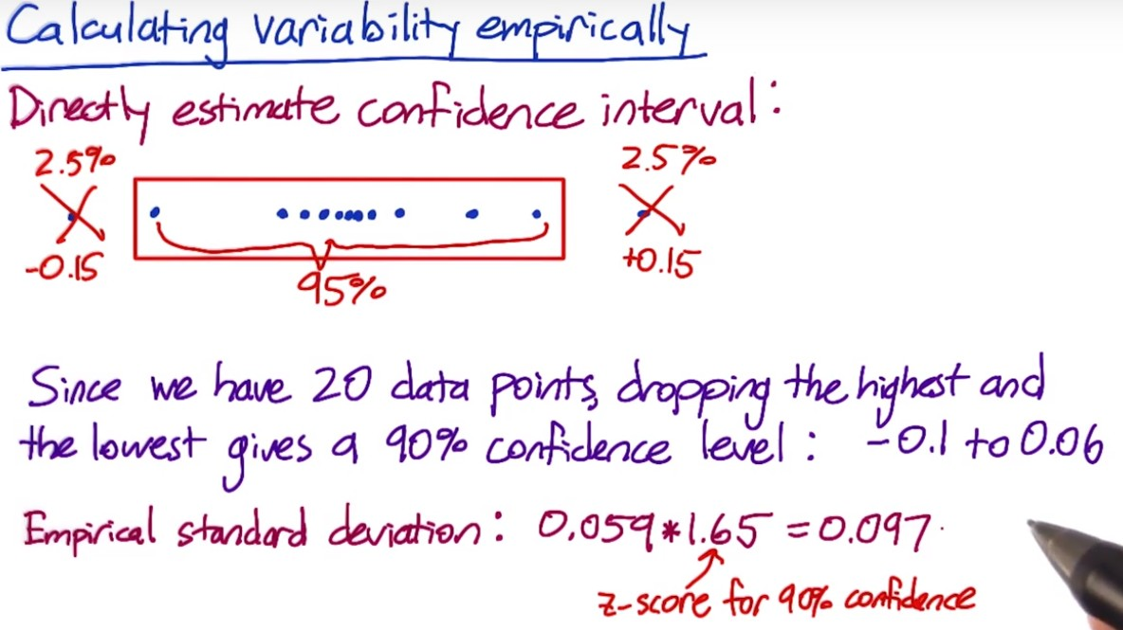

Can try to run more A/A tests to get more data points to get a more robust empirical confidence interval.

**Bootstrapping:**

If you don’t want to run a lot of A/A tests – run one A/A test – although it is just one experiment, it is calculated from a lot of individual data points (individual clicks and page views). Take random sample of data points from each side of the experiment, and calculate the click-through probability based on that random samples as if it was a full experimental group. Record the difference in click through probability, and use that as a simulated experiment. Repeat this process multiple times, record the results, and use them as if they were from actual experiment.

* i.e. create bootstrapping samples from one big A/A sample.

Different metrics might have different variabilities. For some metrics, their variability is so high and it’s not practical to use them in the experiment even if the metric makes a lot of business or product sense. To calculate the variability, we need to understand the distribution of the underlying data, and do the calculation by using analytical or empirical techniques.

**Lessons learned:**

**(1) Definitions and data capture**

* Click-through-rate: clicks divided by impressions or page views? The first page of the search results, or all the next pages? US only or globally? Removing spams or not?
* Latency – how long it takes page to load: when does the first byte load? Last byte load?

Need to agree on what metric you are using.

**(2) Sensitivity and robustness**

* Latency – can be very lumpy. The mean might not move much, as users might have different connection speed, computer problem, older version of the browser… all these cause the lumpiness in the distribution.

Should we use higher percentage? Need to choose a reasonable higher percentile that can move when we’ve done something positive to improve the latency experience.

* Search – tasks per user per day. A very stable metric. Does not change much with the experiments. What time period makes most sense? Per day or per week?

Does your metric has a lot of weekly variation? If so, 28-day makes more sense than 30 days.

**(3) Variability**

* Good to start with analytical characterization of variability, and in some cases might be sufficient, or it may give you a good sense on how you want to size your experiment to at least tell if you are in the ballpark.

For some metrics, easier to compute empirically than analytically.

* The necessity of sanity check/invariability

e.g. number of search results to show. Should keep latency as invariant as opposed to evaluation metric.

**Design Experiment**

**Subject:**

decide how to assign events to either the control or experiment

**Unit of diversion** is how we define what an individual subject is in the experiment – look for proxy for users

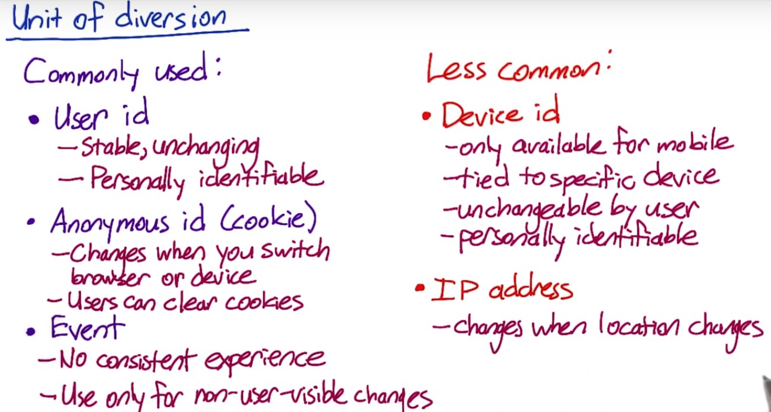

User id and anonymous id are different approximations to actual user or person, and event is just the singe event.

**(1) User id:**

Could be login information user created, such as user name or email. The events correspond to the same user id are either in the control group or in the experiment group, and they are not mixed between the two groups.

User id is considered personally identifiable as it is usually tied with personal information for purposes such as account recovery.

**(2) Anonymous id:**

e.g. cookie – website will write a cookie when users visit, and cookie is always associated with a browser and device. Easier for people to change cookie than user id, and users can clear cookies.

**(3) Events:**

Means for every single event, you redecide whether the event is in the control or in the experiment. Users might not get a consistent experience at all, and is only appropriate for situations where the changes are not user visible. – e.g. change the rank order of the listing. This might result in getting a mix of actual users on both sides, so only applicable to cases in which this does not matter.

(4) Device id:

Might not have the cross device and cross platform consistency that user identifier might have.

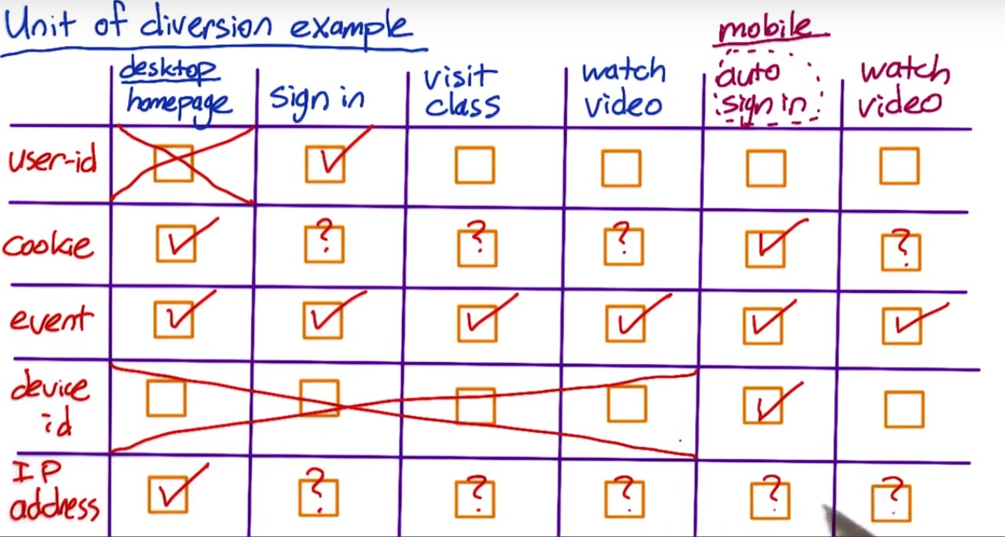

Notes:

* User id – the user will be assigned to a group when they first signed in, and that assignment would not change even if they log in using other devices / platform in the future. Cannot assign a user to any group before login.
* Cookie-based: re-assign every time when cookie changes. Assign when the first cookie is created (open a home page in this case). If user clear cookies at any point, then reassignment will happen.
* Event-based: Every single event, will reassign
* Assign the group at the start of the mobile experience. Typically do not have device id for non-mobile devices.

**Considerations for user diversion.**

**A. Consistency**

**(1) User consistency:**

* If using user id, user get consistent experience as they change devices as long as they stay signed in
* If you test a change that cross the sign-in and sign-out border, user id might not work well. e.g. location of a sign-in bar, layout of a page. In such cases, can use cookie so that you can stay consistent across and the border of sign-in and sign-out, but not across devices.

**(2) User Visibility:**

For user visible changes, should always consider using a user id or cookie as unit of diversification. For changes not visible to users, such as latency changes, backend infrastructure changes, ranking changes, should consider event-based diversification.

**(3) what you want to measure:**

e.g. learning effect – whether a learner adapt to change. Might still want to use user id or cookie.

e.g. latency change whether the user use the site less – might still choose user id or cookie although the change is not visible. Totally depends on the measurement you are trying to get.

IP base diversion – not very useful, do not get the consistency. User’s IP address could randomly change depending on what happened with the provider, and do not get the clean randomization that you get from event-based diversion.

But IP-based diversion might be your only choice in some situations – e.g. test an infrastructure change when testing hosting providers to understand the impact of latency.????

IP-based diversion- challenge is around the analysis. Might not get a clean comparison between the experiment and control. e.g. modem dialups. For some providers, they aggregate all the modem dialup users into one IP address – how should I find the comparable population of the users in my control? need to do lots of post analysis to find the good comparison between experiment and control.

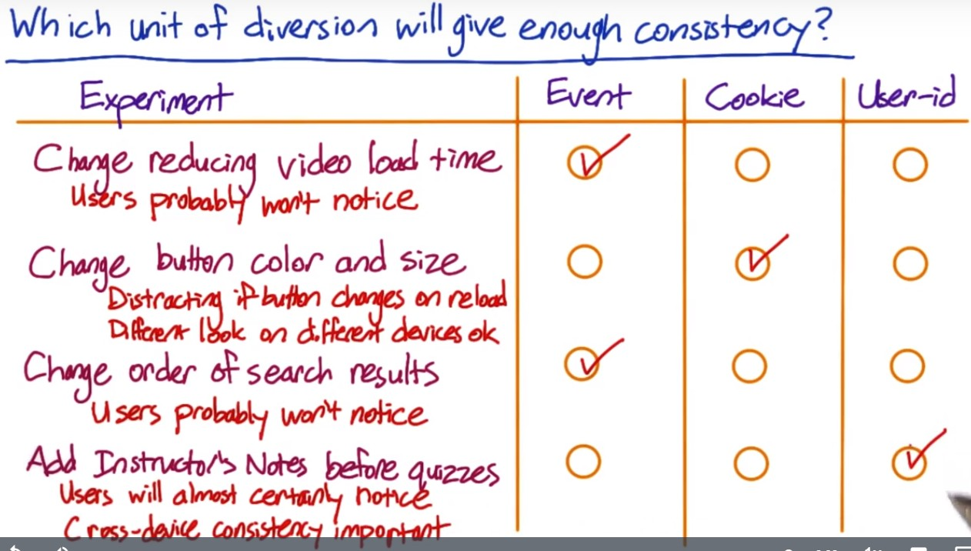

For the first and third one, there could be learner effect. Can start with event-based diversion, and switch to cookie-based in the future if necessary.

**B. Ethical Considerations**

If you use user id, then it is person identifiable, and there will be security and confidentiality concerns to address, and might need to get user consent.

This is less of an issue for cookie based diversion. 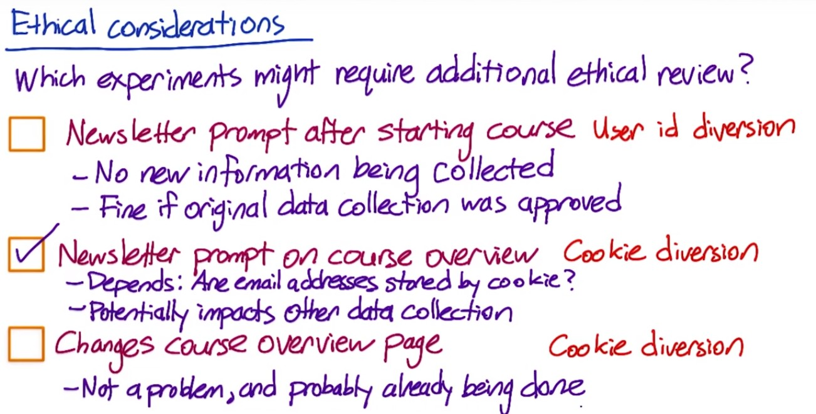

Case #1. The newsletter signups were already stored by user ids.

Case #2. Email is stored by cookie. Might make the cookie non-anonymous.

**C. Variability Considerations**

**Unit of analysis – the denominator of your metric**

e.g. click-through rate = clicks / page views – page view is the unit of analysis. In the case of event-based diversion, page view is also the unit of diversion. Therefore, the analytical variability will be very close to the empirical variability.

However, if unit of diversion is cookie or user id, the actual variability might be a lot higher than what was calculated analytically. Therefore, should move to use empirically calculated variability.

This is because when calculating the analytical variability, you are assuming:

* The distribution of the underlying data
* What’s going to be considered as independent

If you use event-based diversion, you assume each event is independent. But if you use user id or cookie based diversion, the independence assumption is no longer valid, as you are diverting groups of events and they are actually correlated.

**Conclusion – change unit of diversion can dramatically change the variability of the metric.**

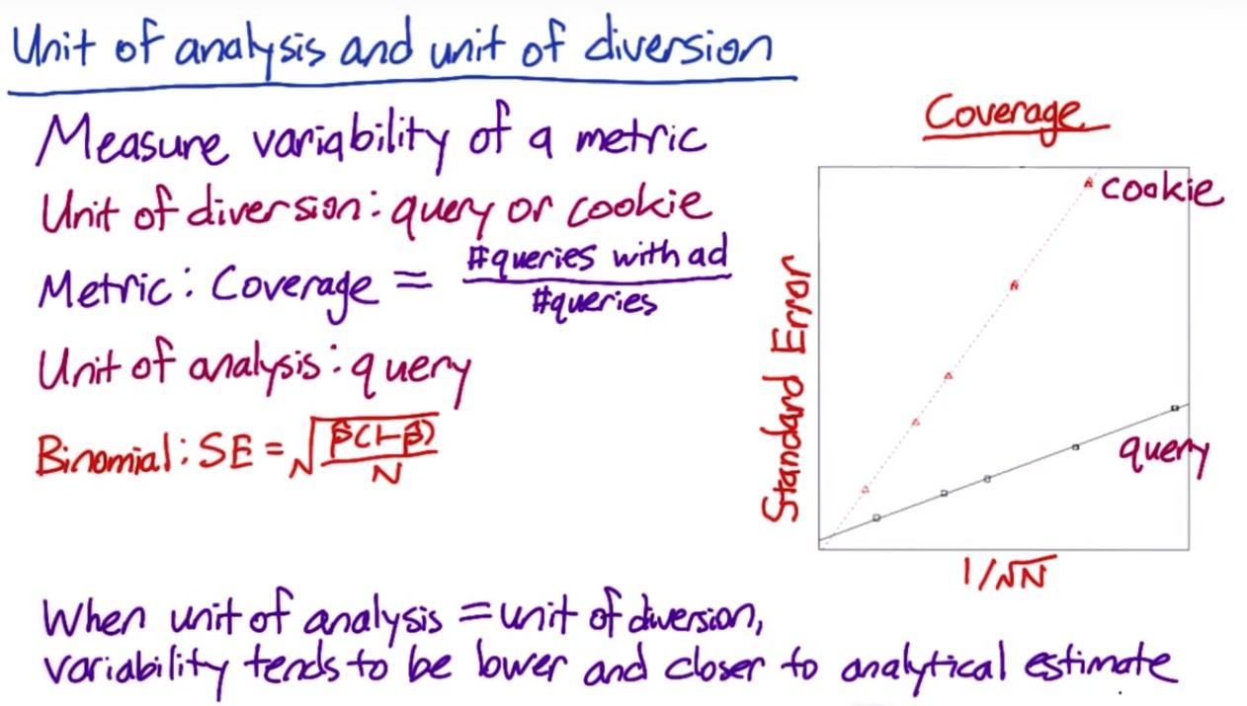

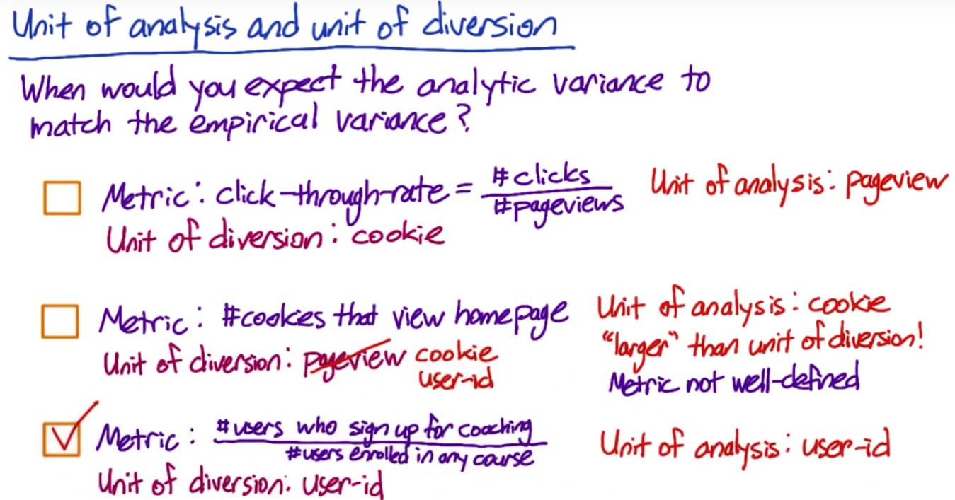

Unit of diversion should be at least as big as unit of analysis; otherwise the same event might correspond to different groups, and the metric is not well defined.

**Inter and intra**

Intra-user experiments: expose the same user to this feature on and off over time, and analyze how users behave in different time windows.

* Need to choose a comparable time window.
* Also with a lot of features, there might be frustration or learning problems, where users learn to use the particular features in the first two weeks, and ask why when you turn it off.

Rank order list – can run interleaved experiments where you expose the same users to A and B at the same time.

Mostly for A/B test – inter user – different users on A and B sides.

### Interleaved experiments

In an interleaved ranking experiment, suppose you have two ranking algorithms, X and Y. Algorithm X would show results X1, X2, … XN in that order, and algorithm Y would show Y1, Y2, … YN. An interleaved experiment would show some interleaving of those results, for example, X1, Y1, X2, Y2, … with duplicate results removed. One way to measure this would be by comparing the click-through-rate or -probability of the results from the two algorithms.

**Target Population**

Need to decide who you are targeting in your users – there are some easy divisions to consider, such as browsers, geo locations, country, language, etc. how long have been used your websites. Demographic information such as age, etc.

Make this decision in advance.

* High profile launch – want to restrict the number of people who see it before official launch to avoid press coverage.
* If want to run internationally, need to check if the language is correct.
* If not sure if your experiment works on older browsers, might limit the experiments only to modern browsers.
* Avoid overlapping between various experiments
* Only run your experiment on the affected traffic. Filtering the traffic might affect the variability as well. **Run the experiment with global data with unaffected population included might dilute the changes.**

Cases in which don’t choose particular traffic:

* Cannot ID the population that is affected by the feature
* Want to test the effect across global population as not sure if you can target correctly
* 90% of the total traffic might be affected, and does not worth the trouble to find the specific target
* Need to check with engineering team to better understand the features. – trigger for any particular browser? Concerned for potential interactions so that we might want to run a global experiment
* Should use the same filters for the target and untargeted of the experiments.
* Before launching a big change, run a global experiment to make sure you do not have unintentional effect on the traffic you were not targeting

Example for diluting the results:

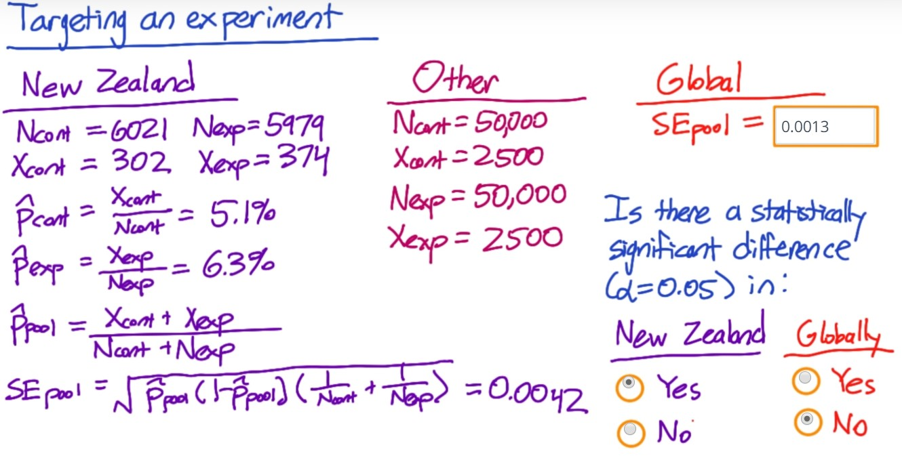

**Populations vs. Cohort**

Cohorts- subset of populations for users entering the experiment at the same time

Define an “entering class”, and only look at users entering both sides **at the same time**.

* Can also use other information to define cohort – e.g. users have been using your site consistently for 2 months, users with both laptop and mobile associated with their user ID, etc.

Cohorts are harder to define and require more data as we are losing some users.

Typically, cohorts are used when looking for user stability (e.g. measure learning effects, increased usage of your site/device, etc.), when you want to observe how your change affects users’ behaviors instead of their history.

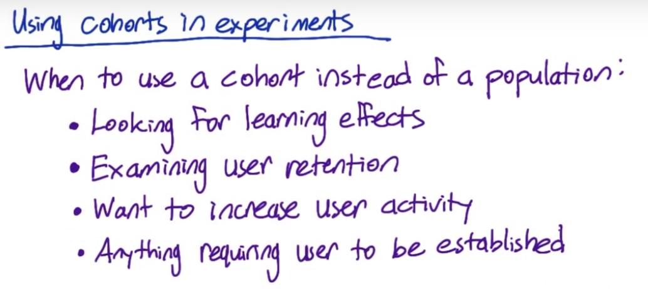

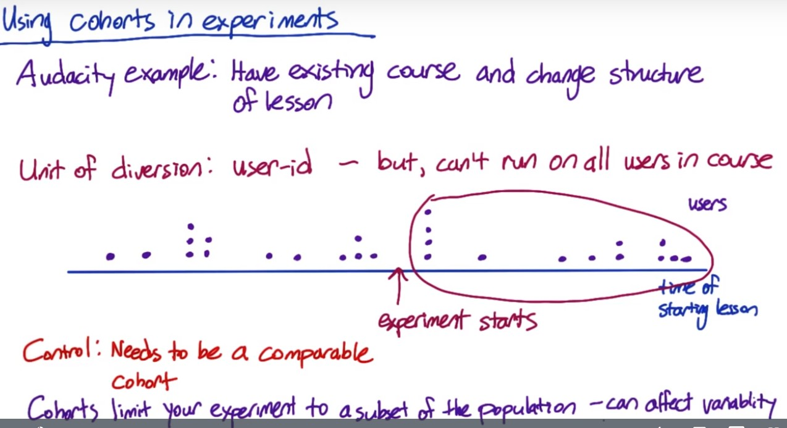

Cannot use the users who have started the courses before the experiment, because don’t know whether they have completed that lesson already. Choose cohorts of users that start after the course after the experiment starts, and split them between control and experiment groups. Cannot use the cohorts before the experiment start for control either, as there might be some other system changes that affect the experience.

**Sizing:**

Choice of metric, unit of diversion, choice of population – these may affect the variability of the metric. Take these into account and determine the size. Figure out whether what you plan to do is realistic given how long it takes to run the experiment and the variability of the metric.

* Page load time – 90th percentile of latency, this can be based on pageview. But if we want to measure if users increase the use of the site more based on the latency they experience, then need to use user id diversion. This will require a lot of user data, and if the original plan was to use global data, it might not be realistic and will take a long time. Maybe consider people with slow connection, and cohort for people who uses our sites for more than 2 months. This restriction can result in a smaller scope of the project and can give you a better sense on whether you can get a signal out of the experiment at all before you make a big investment.

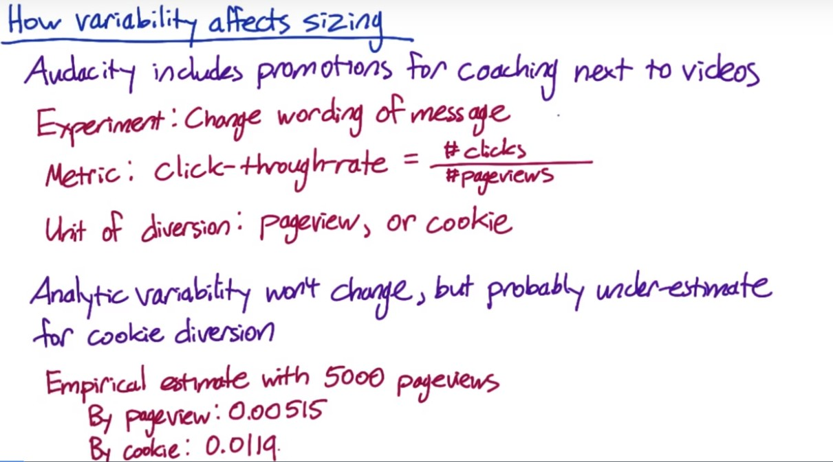



Course click-thru-rate= total number of clicks on any course/total number of pageviews

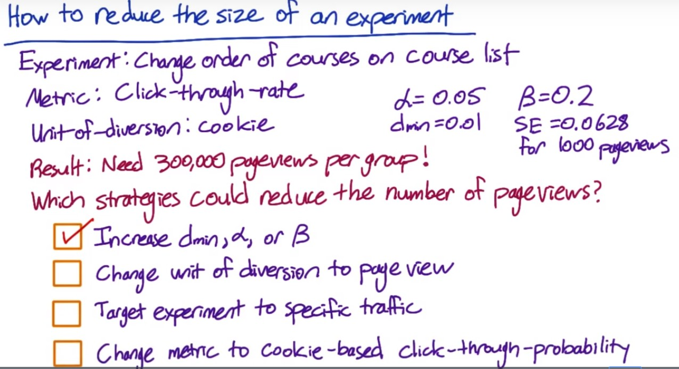

#1. Refer to lesson 1.

#2. Variability of the metric decreases – you need less populations to be comfortable with the result. Only question is – will the less consistent experience be acceptable?

#3. Might take more time overall to find English traffic, but can run other experiments on non-English traffic in the mean time so still worth to do it. Including non-affected populations will dilute the result, which will increase the pageviews needed.

Could also affect the practical significance boundary. Since only looking at a smaller population, might need to choose a bigger change that matters to the business; or since variability is lower, might want to take advantage of that and detect smaller changes rather than decreasing the size of the experiment?????. Practical significance could move in either direction – but it is likely that variance would go down, and practical significance boundary will increase, which will decrease the popultion???

THIS DOES NOT MAKE SENSE

#4. Especially if you are using a short window for the probability – so could reduce but might not help much.

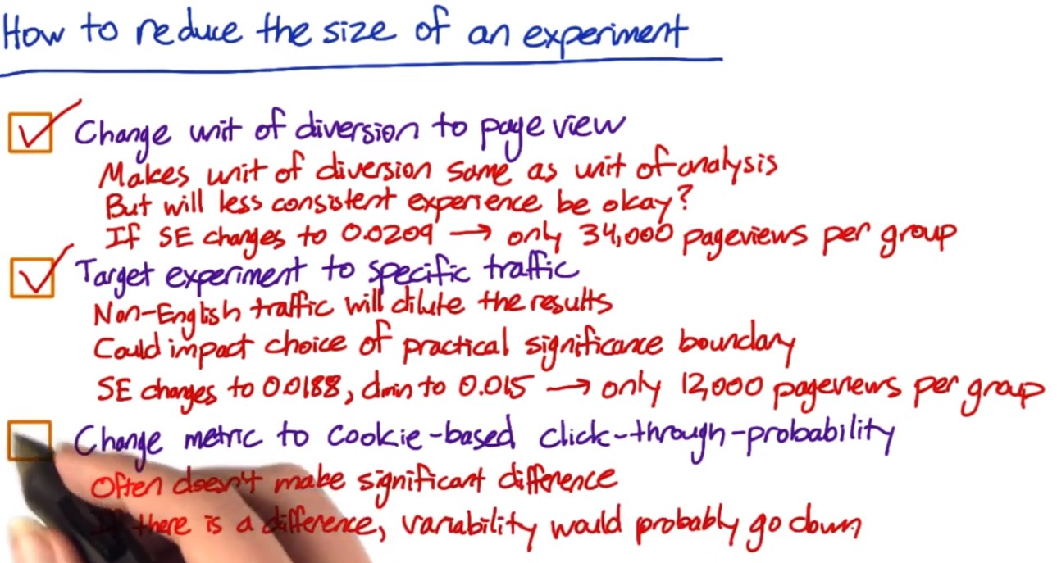

Note: for case #3, the variability on the targeted traffic is obviously greater than the group. Should not use the variance relationship with the number of populations to make judgment any more, and the base population is already different.

There might be cases in which you don’t know which fraction of the population is going to be affected by the changes of the feature – need be conservative about the time needed for the experiment. Can run a pilot experiment, or just observe the experiment for the first couple of weeks to check which fraction is affected.

Duration of experiment, and when to run? Holiday season, any overlap with any event?

What fraction of population to send through the experiment.

e.g. cookie-based diversion – what percentage of cookies are you sending to your experiment and control? The duration of the experiment is related to the percentage of traffic you are sending to experiment and control each day. More traffic per day, less time.

* Safety consideration: e.g. new feature and not sure how users will react. So keep the site the same to most people and only expose it to small portion of people.
* Press: want to limit the coverage.
* Might want to run a small percentage on everyday including weekdays and weekends, instead of a single day (especially holiday) to account for other sources of variability – a time frame that is representative.

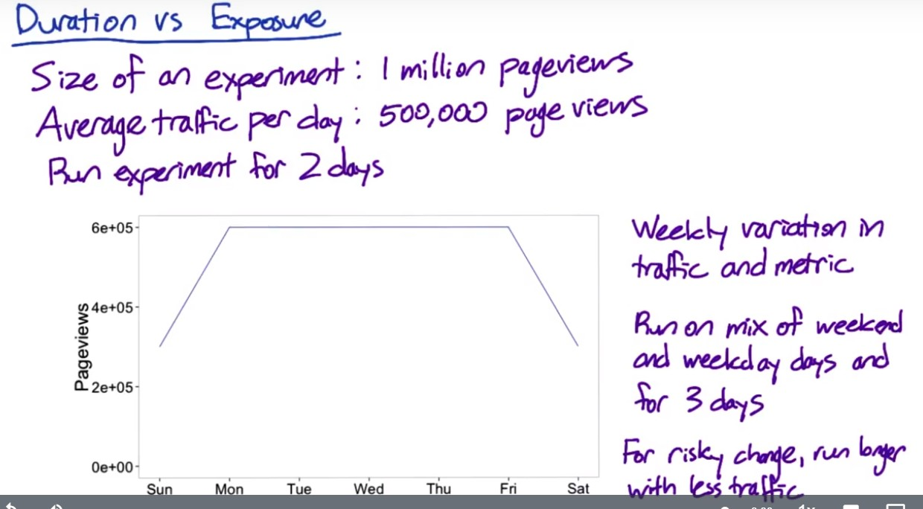

Run 3 days instead of 2 days to get enough traffic, since the weekend does not have enough traffic.

Question- why run it longer will result in less total traffic?? – total per day?

Run the experiment longer, but reduce the number of users exposed to the change.

**Learning Effect**

Users adapt to the changes.

* This takes time, but we usually do not have enough time for this to make decision.
* Choose the unit of diversion correctly to capture this, such as user id and cookie.
* Learning is also about how often (dosage) users see the change – use a cohort instead of the entire population, based on how often they have been exposed to the change or how long they have seen it.
* Duration: this might take some time to see what is happening, don’t want to put lots of users as might want to use for other experiments.
* Risks: for learning effect, probably not certain about how it changes, which means there would be risks. So should run through a small portion of users over a longer period of time.
* Pre-period and post-period. AA tests before and after the experiment. Differences observed in post-period, can attribute to the learning effect.

Analyze the AB Test Results

**Sanity Check**

Examples:

* Unit of diversion – experiment and control should be comparable
* Set up filters consistently between experiment and control
* Is data capture set up accurately capturing the events you are looking for?

**Use invariants to do sanity check – two types:**

(1) population sizing metrics based on unit of diversion

Experiment population and control population should be comparable.

(2) other invariants – the metrics that shouldn’t change in your experiment

Should test if these metrics change or not.

Should choose the invariant metrics based on the feature you are changing and where it falls under the overall process. E.g. if the feature affects the steps from #4, then the metrics associated with steps before #4 can be used as invariant metrics.

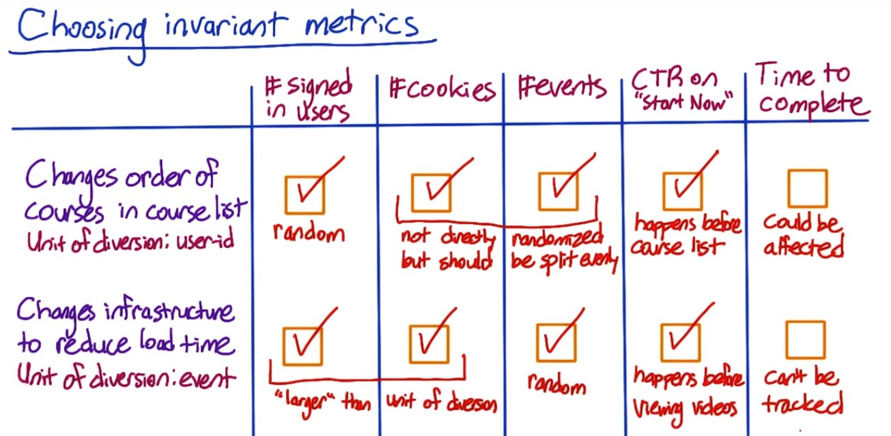

Case #1.

Since user id is used as unit of diversion, cookies and events might not be exactly the same between control and experiment, but should not vary too much unless users visit the pages significantly differently between the two groups. If that’s the case, it needs to be further investigated. Time to complete might be affected as students might start with easier course based on the new order.

Case #2.

Hard to track as the unit of diversion is event

Not a good invariant as load time could affect time to complete a course.

Question – larger unit should be equally split?? Why?

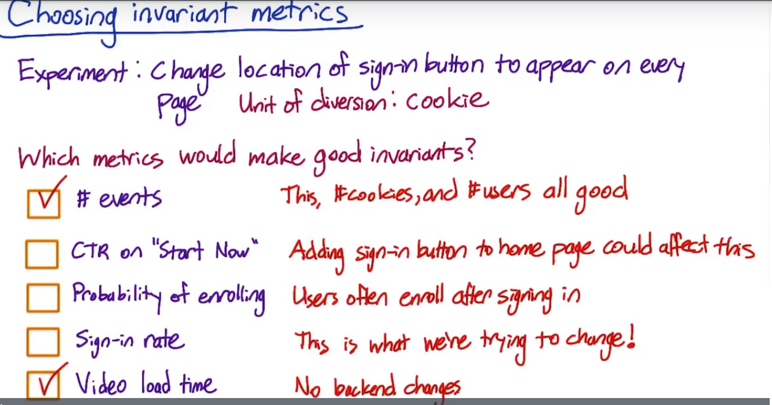

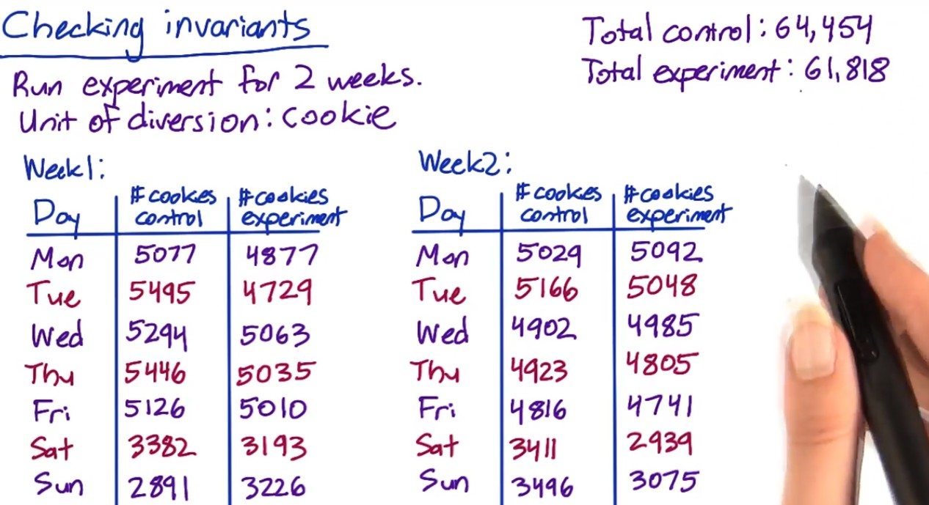

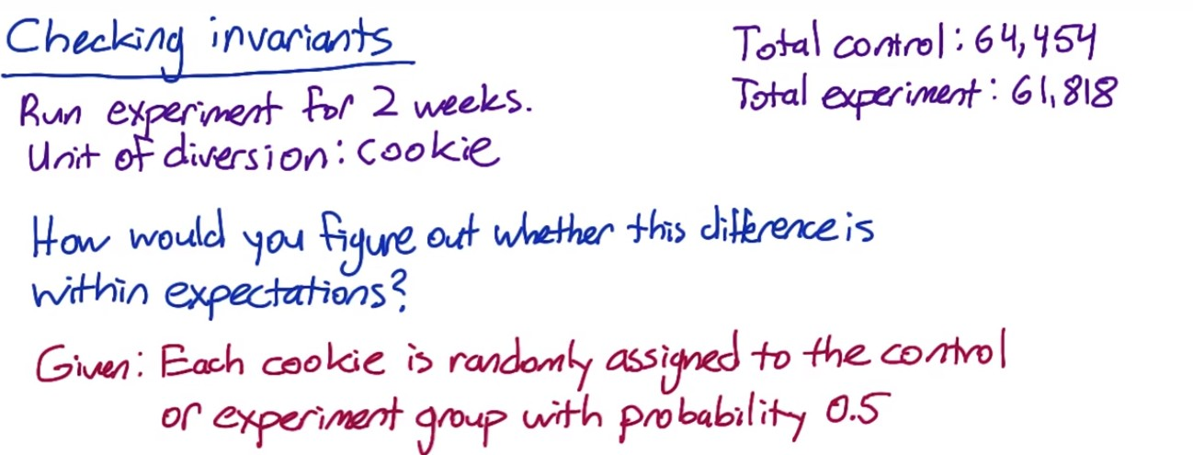



Use p=0.5 to calculate the confidence interval. The observed fraction of control group is greater than the upper bound of CI, so there is something wrong with the setup. Do day-by-day analysis:

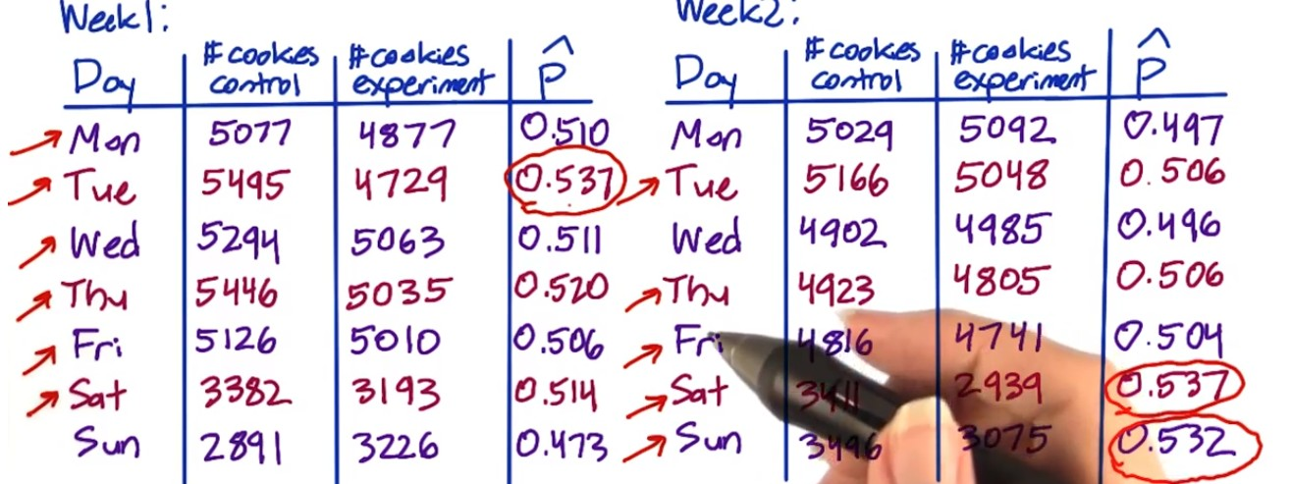

Control group samples are more on a lot of dates not just a specific day.



The slice could be country, language, or platform.

What to do if you find issues during the sanity check

(1) Issues to check with the engineering team:

* Experiment infrastructure
* Unit of diversion

(2) Retrospective Analysis

Recreate the experiment diversion from the data capture to understand if there is something endemic to what you are trying to do that might cause the situation.

(3) Pre and Post period

If observe changes for invariant metrics on post period, check if similar changes exist on pre period. If so, there could be problems with the experiment infrastructure, setup, etc. If the changes is only observed on the post period, it means the issue is associated with the experiment itself such as data capture.

The most common thing – data capture. Maybe the changes trigger rarely, and you capture it correctly under the experiment but not the control.

Experiment setup – didn’t set up filter correctly between control and experiment.

More rarely could be system issue such as cookie reset (need to dig deeper and find out with engineering team)

Learning effect may take time. If the issues are observed at the beginning of the experiment, might not be learning effect.

Analyze the results.

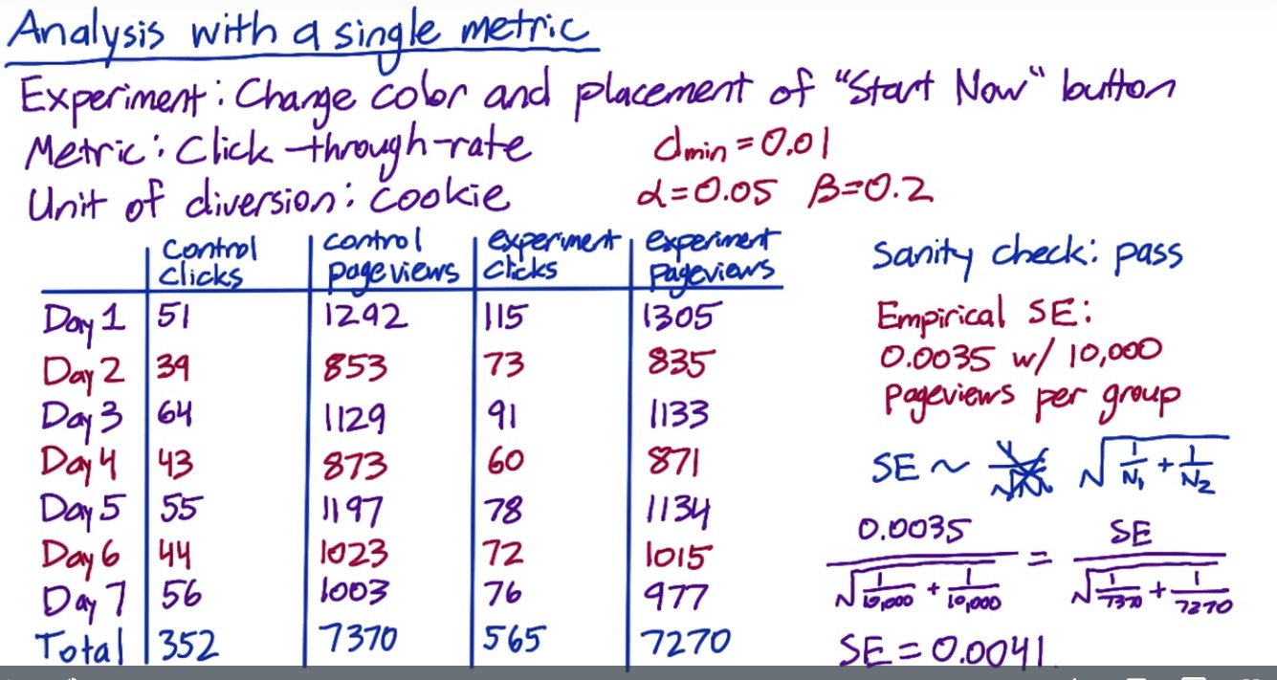

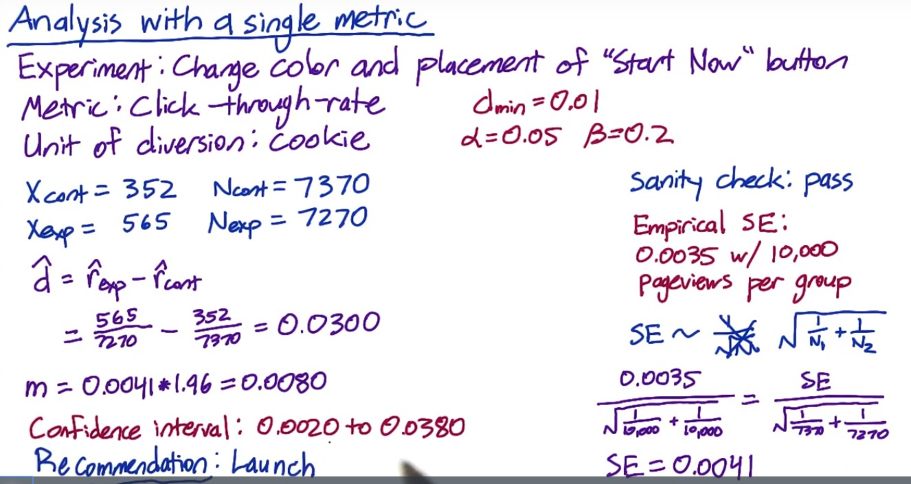

Unlike click-through probability, click-through rate more follows Poisson distribution and the analytical variance is harder to estimate compared to Binomial. Need to analyze it empirically. Typo: 0.022 – 0.038. practical significance is out of the CI, meaning the difference is significant to be captured, and the change should be launched.

Question: SE is linear to square root of 1/N and this is based on binomial distribution assumption. Why does this still hold for Poisson? How was 0.0035 collected? The scaling factor applied on the SE is unclear.

**Sign Test:**

Approach was not clearly explained

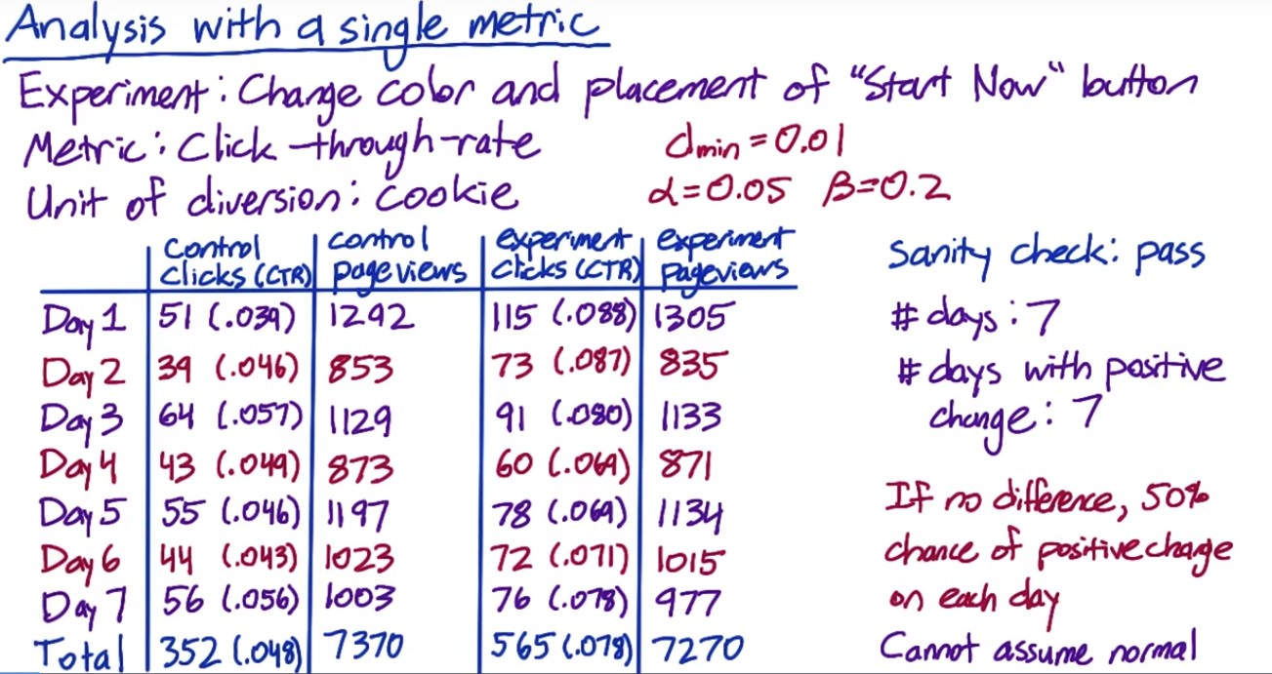



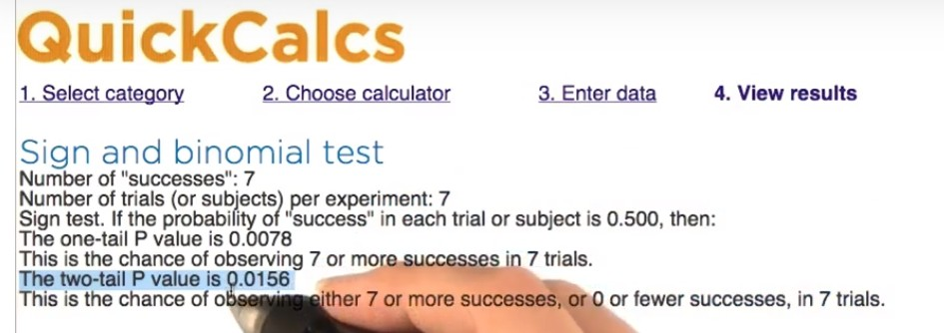

Another example:

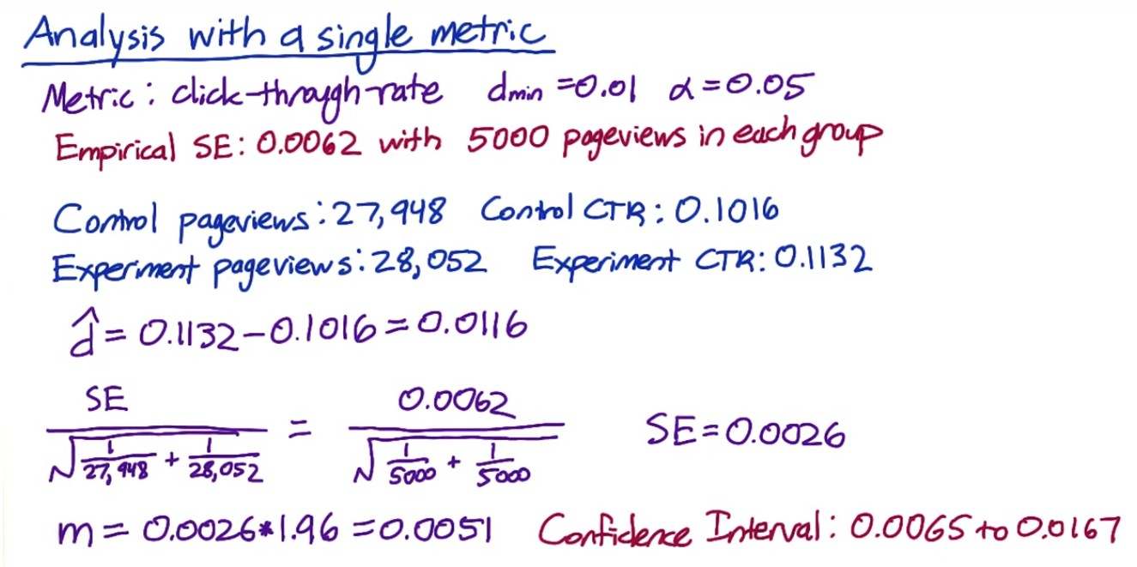

The CI does not include 0 – indicating that the difference is at 95% level significantly different from 0. But 0.01 is included, indicating that cannot be 95% confident that the change is greater than 0.01 – i.e. the size effect we care about.

Sign test:

Sign test is not significant and has less power compared to size effect, which is normal. Might not be a red flag but can dig into it – break down by day.

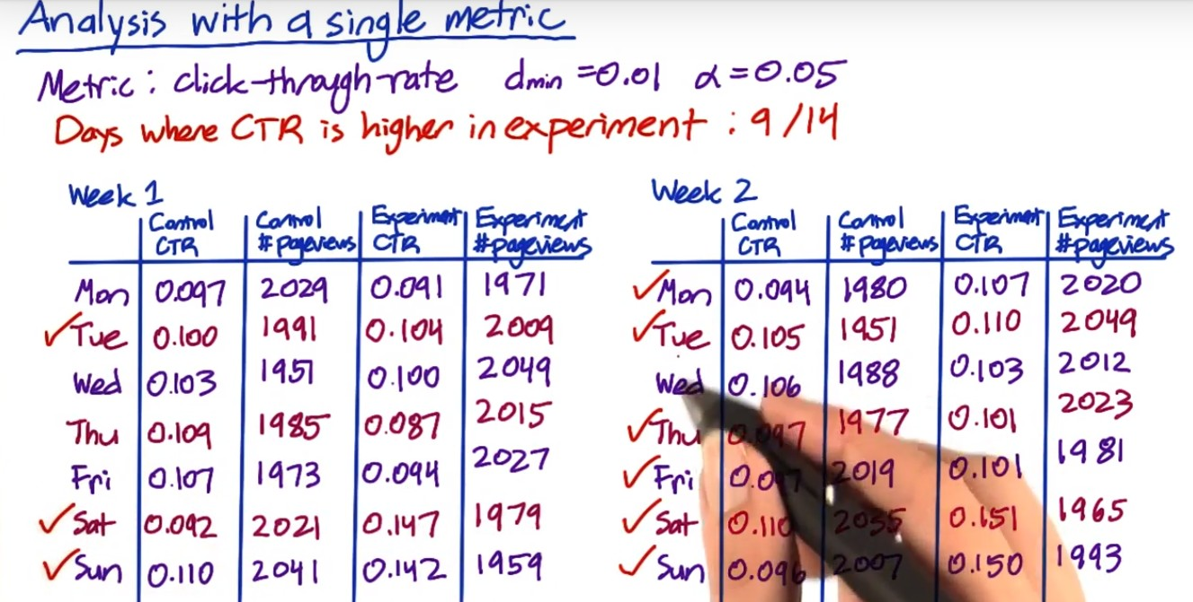

Weekend click-through rates are much higher than weekdays. Size effect on weekends are a lot higher.

Hypothesis test and sign test conclusions do not agree.

Need to take a look at the feature functions to see if it really functions differently for different sub-groups (e.g. platform).

Simpson Paradox: different subgroups in the data, within each group the results are stable, but when aggregated the mix of the subgroups drive the results.

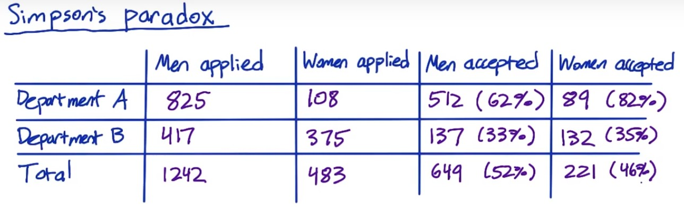

Women’s acceptance rate is higher than men in both departments, but the overall acceptance rate is lower. This is because most of the women applied to department B, whose acceptance rate is lower than A.

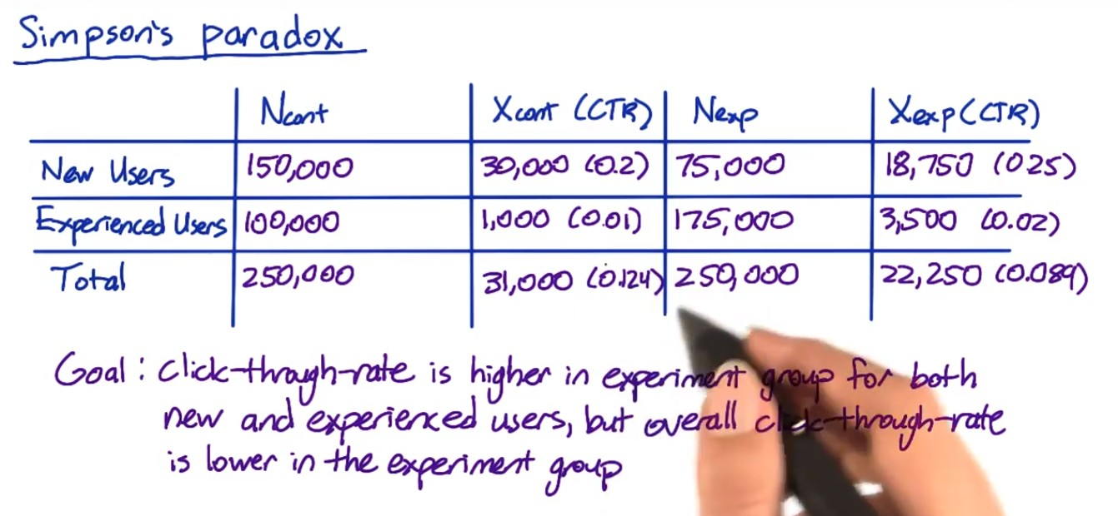

CTR for experiment group is higher than control for both new users and experienced users. But for total users, control group CTR is higher. This is because control group has more new users, which has higher CTR and experienced users.

**Indicating that in addition to control/experiment group, there is another dimension that would affect the metric.**

* Checking the breakdown across different slices is a good idea during sanity check to avoid this. Otherwise will result in an experiment setup issue like this.
* Another possibility is- experiment setup is fine, but the feature change affects the new and experienced users differently. E.g. the change makes new users generate fewer page views and experienced used generate more pageviews

Therefore, although for each subgroup it seems that CTR has improved, the overall CTR was not improved and cannot say the experiment is successful. Need to dig deeper to understand what caused the difference between new users and experienced users.

**Multiple Metrics:**

As you test more metrics, it becomes more likely that one of them will show a statistically significant result by chance. If you did the same experiment on another day or divide into slices or did bootstrapping analysis, might not see the same metric showing up significance every time. It should occur randomly.

Multiple comparison – adjust your significance level to account for how many metrics and how many different tests you are doing.

Automatic detection of differences.

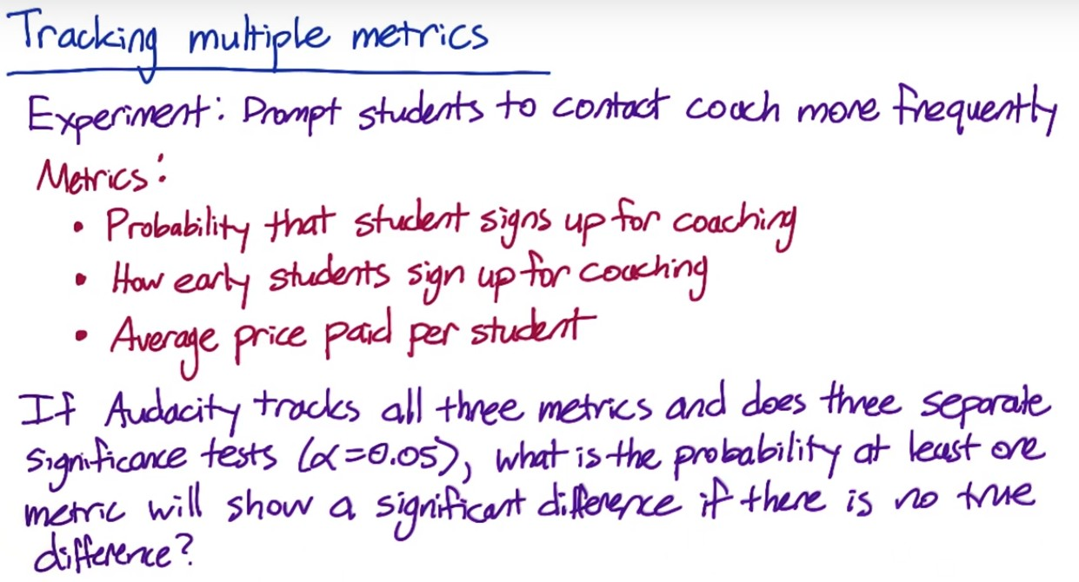

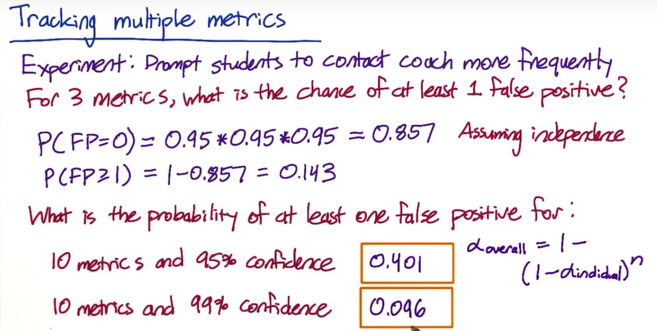

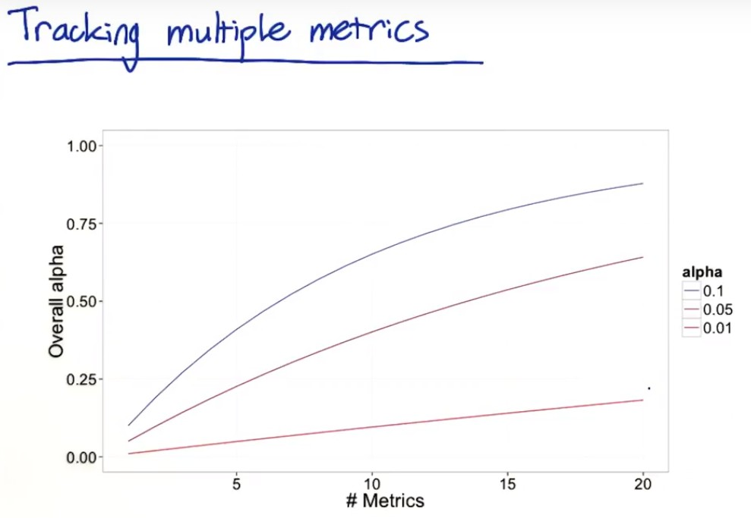

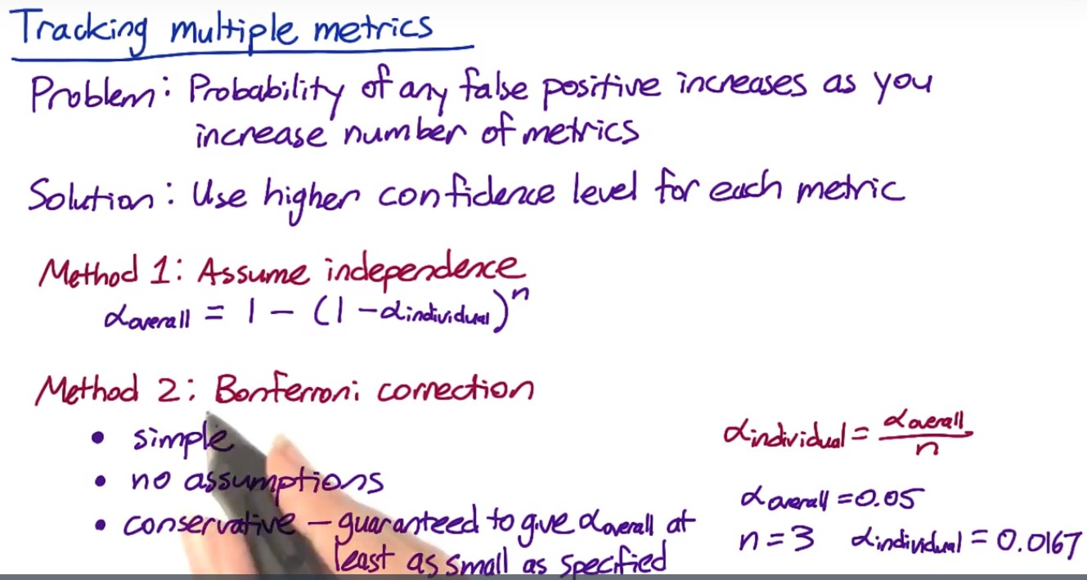

Method 1: set up an overall alpha and use it to calculate each individual alpha.

Method 2: often will be tracking metrics that are correlated and all tend to move at the same time, in which case this method is too conservative – this results in less significant difference, and launch less experiments???.

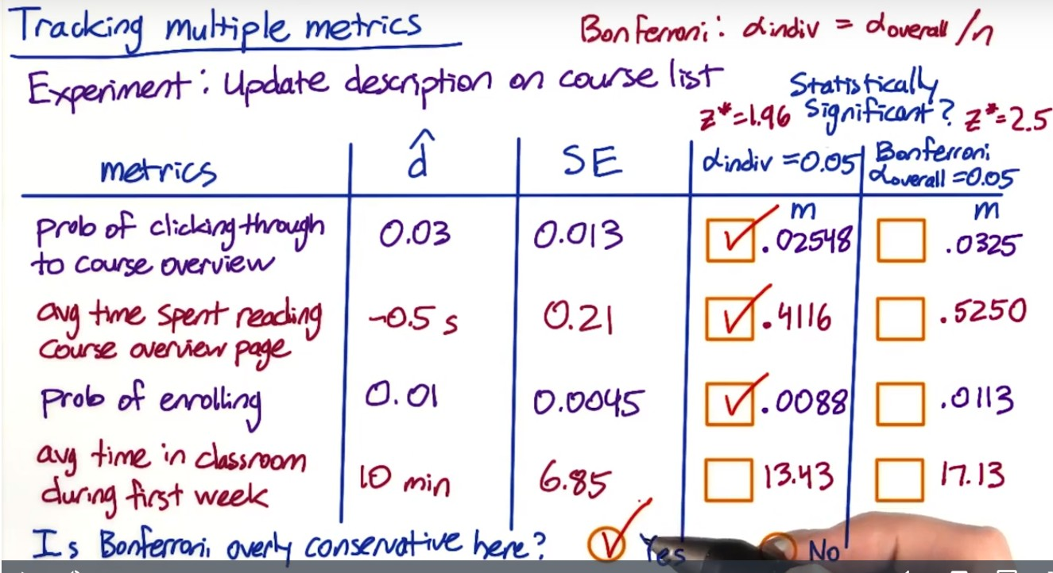

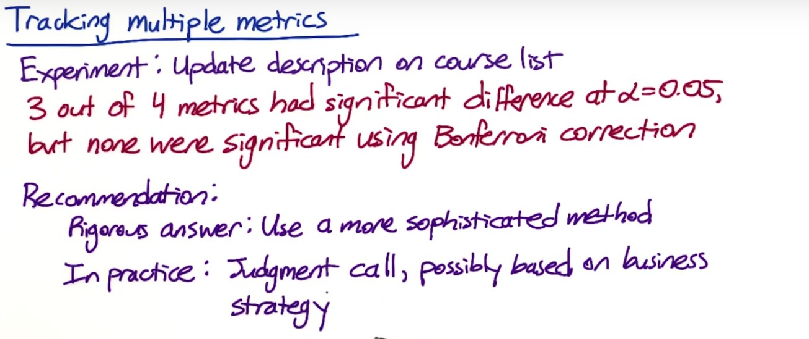

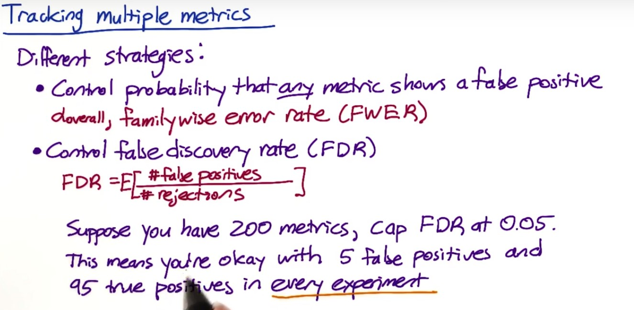

FDR: loose the requirement and allow for some occurrence of false positives as long as there are not too many of them. FWER is 1.

### Less conservative multiple comparison methods

The [Bonferroni correction](http://en.wikipedia.org/wiki/Bonferroni_correction) is a very simple method, but there are many other methods, including the [closed testing procedure](http://en.wikipedia.org/wiki/Closed_testing_procedure), the [Boole-Bonferroni bound](http://en.wikipedia.org/wiki/Bonferroni_bound), and the [Holm-Bonferroni method](http://en.wikipedia.org/wiki/Holm%E2%80%93Bonferroni_method). [This article](http://en.wikipedia.org/wiki/Multiple_comparisons_problem) on multiple comparisons contains more information, and [this article](http://en.wikipedia.org/wiki/False_discovery_rate) contains more information about the false discovery rate (FDR), and methods for controlling that instead of the familywise error rate (FWER).

Analyze the multiple metrics

Are all the related metrics moving in the same direction – e.g. click-through rate and click through probability.

Revenue per thousand queries is composed of click through rate and cost per click

Stay time on the page vs. clicks on the page – people might spend more time on clicking than staying. Need to better understand how people reacts to the changes.

Overall evaluation criteria (OEC) should be established based on an understanding of what your company is doing and what the problems are. It should balance long-term and short-term benefits. Business analysis is needed to make the decision. Once you have some candidates of OEC, you can run a few experiments to see how they steer you (whether in the right direction).

Change in metric and not others:

* Maybe you know for small changes, a change in one metric and not others might be fine.
* But for big changes, this may indicate something is wrong. Depends on your understanding of the changes itself.

Different impact across slices:

* Again need to understand the changes. Is there a bug? Have you seen this in other experiments? Is this because of different users (like or do not like the change)
* e.g. bolding works better in English/German than Chinese/Japanese. May consider using color than bolding for Chinese/Japanese.

Whether to launch an experiment or not??

1. Statistically and practically significant to justify the change?

2. Do you understand what the change can do to user experience?

3. Is it worth the investment?

**Ramp up AB test**

Maybe start with 1% of the traffic and divert to experiment and increase that until the feature is fully launched.

Also remove all filters to test the change on all users to understand if there is any incidental impact to unaffected users that you didn’t test in your original experiment.

Gotcha: the effect might flatten out as you experiment the change – effects are not repeatable even they are statistically significant.

* Seasonality such as school season, holiday, etc.

Holdback – launch the experiment to everyone except for a small holdback who don’t get the change, and you continue to compare them to the control. You will see a reverse of the impact in your experiment, and you can track that over time until you are confident that your results are repeatable. This can help track lots of seasonal or event-driven impacts.

Other things that cause the disappearing launch effect?

* Novelty effect or change aversion: as users discover or change their adoption of your change, their behavior can change and measured effect can change – can do cohort analysis.
* Pre- and post period analysis in combination of cohort analysis to understand learning effect – i.e. how users adapt to the changes over time.

Lessons learned:

(1) Always make sure your experiment setup is correct

(2) In addition to statistical significance, you are making business decision. E.g. what if it improves for 30% and neutral for the rest? Or what if it improves for 70% but makes it worse for the 30% left? Want to launch as is or fine-tune it first

(3) overall business analysis – what’s the engineering cost of maintaining the change? Are there customer support or sales issue? What’s the opportunity cost? These are judgment calls which your recommendation should be based on.

(4) As noted earlier, test for all users for the incidental impact.